Computer Vision

0n

**Pneumonia Detection**

A Capstone Project

Submitted by

**Amol Ahire**

**Deepali**

**Shruthi J**

**Swagatika Mohapatra**

**Ramesh Chandra Yadav**

**Radha Yelisetty**

In fulfilment of the requirement for the award of

Post Graduate Program in Artificial Intelligence & Machine Learning

from



&



**Contents**

**Contents………………………………………………………………………………………………………………………… ii**

**Abstract…………………………………………………………………………………………………………………………..iii**

**1.Introduction…………………………………………………………………………………………………………………..1**

*1.1. Symptoms………………………………………………………………………………………………………………….1*

*1.2. Key Facts…………………………………………………………………………………………………………………...1*

*1.3. Pneumonia Detection……………………………………………………………………………….………………..2*

*1.4. Business Domain Value………………………………………………………………………………..…………….2*

**2. Summary of the project……………………………………………………………………………………..2**

*2.1. Project Description……………………………………………………………….………………………...2*

*2.2. Data Description…………………………………………………………………………………………….3*

*2.3. Project Objective………………………………………………………………………………………….…3*

**3. Summary of the approach to EDA and Pre-processing………………………………………...3**

**4. Summary for Interim report……………………………………………………………………………...11**

**5. Deciding Models and Model building…………………………………………………………………11**

*5.1. CNN Architecture………………………………………………………………………………………..…12*

**6. Conclusions……………………………………………………………………………………………………....14**

**Abstract**

Pneumonia, a lung infection, manifests when viruses invade the lungs' alveoli or air sacs. In medical diagnostics, artificial intelligence (AI) and machine learning (ML) have been harnessed to enhance the precision of disease identification through medical image analysis. This research introduces a Convolutional Neural Network (CNN) model, designed from the ground up, for the classification and detection of pneumonia using chest X-ray images. Distinct from methods that solely depend on transfer learning or conventional handcrafted techniques, our unique CNN model extracts features directly from the chest X-ray images to ascertain whether an individual has pneumonia or not. This approach seeks to address the frequent reliability and interpretability challenges encountered in medical image analysis.

**Keywords**: Pneumonia detection, x-ray imaging, early diagnosis, deeplearning, automation

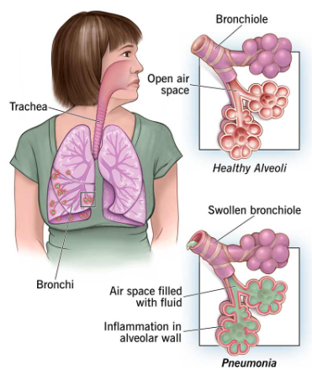**1. Introduction**

Pneumonia is an inflammation of the lung's air sacs, potentially affecting one or both lungs. This inflammation can lead the sacs to fill with fluid or pus, resulting in symptoms such as coughing with phlegm or pus, fever, chills, and difficulty breathing. Various agents, including bacteria, viruses, and fungi, can trigger pneumonia. While its severity can vary from mild to life-threatening, pneumonia poses the highest risk for infants, young children, seniors above 65, and individuals with underlying health conditions or compromised immune systems.

***1.1. Symptoms***

The symptoms of pneumonia can range from mild to severe, influenced by the causative agent, the patient's age, and overall health. While milder symptoms can mimic those of a cold or flu, they tend to persist longer. Potential symptoms of pneumonia include:

* Chest discomfort or pain during breathing or coughing
* Confusion or altered mental clarity, especially in adults over 65
* Persistent cough, potentially with phlegm
* Profound fatigue
* Fever accompanied by sweating and shivering chills
* Below-average body temperature, particularly in adults over 65 and those with compromised immune systems
* Nausea, vomiting, or diarrhea
* Difficulty in breathing

For newborns and infants, the signs might be subtler. They might not exhibit obvious symptoms, or they might display vomiting, fever, coughing, restlessness, fatigue, breathing challenges, or difficulties in feeding.

***1.2. Key Facts***

Following are some of the key facts about Pneumonia which needs at most attention to address the problem proactively.

* Pneumonia accounts for 15% of all deaths of children under 5 years old, killing 808 694 children in 2017.
* Pneumonia can be caused by viruses, bacteria, or fungi.
* Pneumonia can be prevented by immunization, adequate nutrition, and by addressing environmental factors.
* Pneumonia caused by bacteria can be treated with antibiotics, but only one third of children with pneumonia receive the antibiotics they need

***1.3. Pneumonia Detection***

To diagnose pneumonia, it's essential to identify inflammation in the lungs. In this project, our goal is to develop an algorithm that can pinpoint visual indicators of pneumonia in medical images. More specifically, the algorithm is designed to autonomously detect lung opacities in chest radiographs.

***1.4. Business Domain Value***

* Streamlining the detection of pneumonia in chest radiographs by automatically delineating affected areas with bounding boxes.
* Supporting physicians in refining clinical decisions and potentially substituting human judgment in specific healthcare sectors, such as radiology.
* With the aid of pertinent clinical queries, advanced AI methodologies can extract critical information buried within extensive data sets, thereby enhancing clinical decision-making.

**2. Summary of the project**

Pneumonia is an inflammation of the lung, primarily impacting the tiny air sacs called alveoli, usually due to viral or bacterial infections. Diagnosis typically involves symptoms assessment, physical examination, chest X-rays, and blood tests. The severity can vary widely, and in developing countries, many individuals lack timely medical care. Early diagnosis is particularly vital for vulnerable groups such as children and the elderly. In this study, we develop a sophisticated convolutional neural network, trained on thousands of annotated chest X-ray images, aiming to offer swift and precise diagnoses, benefiting both patients and healthcare practitioners.

***2.1. Project Description***

In healthcare, computer vision offers the potential for disease identification. For conditions like pneumonia, it's possible to detect manifestations by recognizing lung inflammation. We've designed an algorithm that pinpoints visual indicators of pneumonia in medical images. Specifically, this algorithm autonomously detects lung opacities in chest radiographs.

***2.2. Data Description***

The dataset contains the following files and folders:

* **stage_2_train_labels.csv**: The training set. It contains patientIds and bounding box/target information.
* **stage_2_detailed_class_info.csv**: It provides detailed information about the type of positive or negative class for each image.
* **DICOM original images**: Medical images are are stored in DICOM files (*.dcm). They contain a combination of header metadata as well as underlying raw image arrays for pixel data.
* A folder “**stage_2_train_images**”: This folder contains all the training dataset chest radiograph DICOM images.
* A folder “**stage_2_test_images**”: This folder contains all the test dataset chest radiograph DICOM images
* A csv file “**stage_2_sample_submission.csv**”: This file contains the patientID and prediction string

***2.3. Project Objective***

The project’s objective is to develop a Deep Learning (DL) based algorithm for the detection of pneumonia in medical images. To achieve this goal, the project comprises several key tasks. Initially, the project involves importing a dataset containing medical images in DICOM format. Subsequently, the images will be mapped to their respective classes, which include categories such as “Normal”, “Lung Opacity” and “Not Normal or No Lung Opacity”. Additionally, the next step involves mapping the images to their corresponding annotations. Following phase focus on the pre-processing and visualization techniques, enhancing the quality of the data and providing the valuable insight into different image classes. Further step aims to display images with bounding boxes, highlight the region of interest. In the final step, the project will encompass the design, training and testing of basic Convolution Neural Network (CNN) models.

**3. Summary of the approach to EDA and Pre-processing**

We have used Jupyter Notebook for coding this Capstone project.

Initials steps performed include

1. Installed pydicom for medical image dataset, as it enable working with DICOM files such as medical images, reports, and radiotherapy objects.
2. Import dataset.
3. Read the labels dataset from stage_2_train_labels.csv.

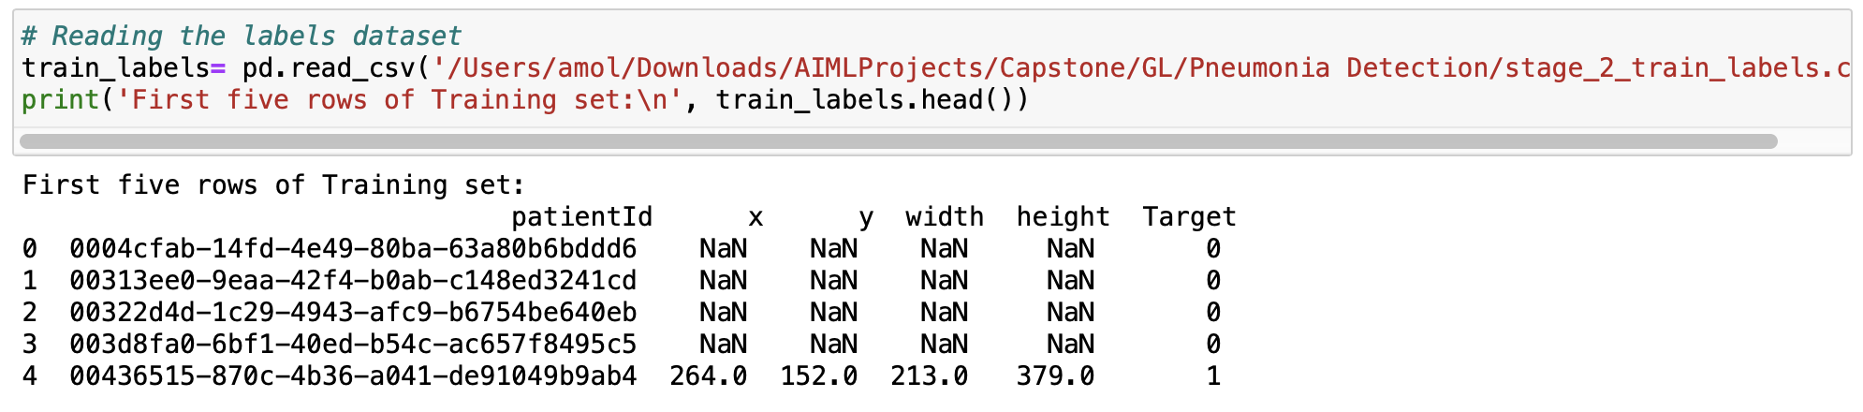

Each row in the CSV file provides details for a patient, denoted by a unique patientId. The 'target' column indicates either 0 or 1, representing the absence or presence of pneumonia, respectively. If present, the abnormality is defined by a bounding box with its upper-left corner coordinates (x, y) and respective width and height. If the patient does not have pneumonia, the bounding box details are recorded as NaN.

Key Observations:

● The train_label dataframe comprises 30,227 entries, spread across 6 columns.

● There are 26,684 unique patientIds, indicating that the dataset holds information for 30,227 patients.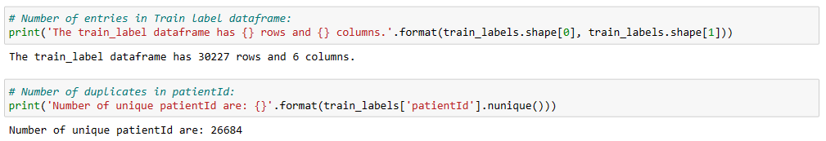

* + Out of these 26684 patients, some of them have multiple entries in the dataset. There are **3543 duplicate entries.**



* + Further analysis of duplicate entry - Checking two of the above patient id which is duplicate, we can see that the x,y, width and height is not the same. This indicates that the same patient has two bounding boxes in the same dicom image.

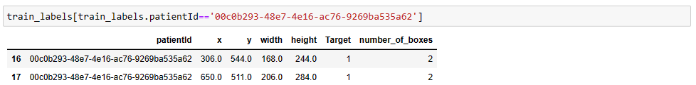

* + 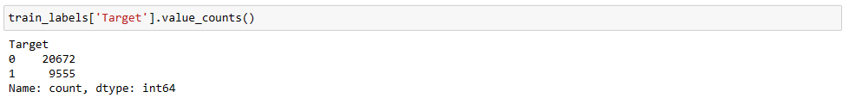Identifying the ‘Target’ count
  + Based on the dataset, below are the target value distribution. There are 22.5% of patients with pneumonia and the remaining are no pneumonia. There is a class imbalance issue.
  + Based on the sample dataset provided – we see that there are 3 class values present.

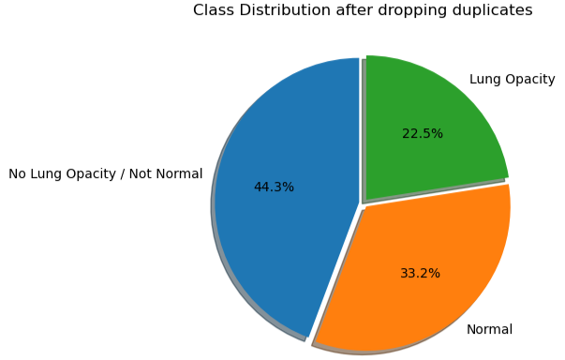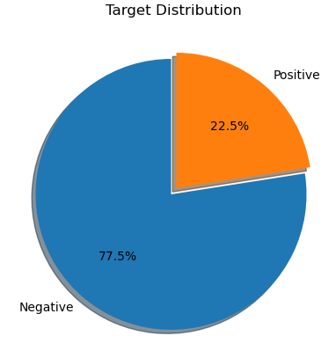

Our objective would be look at images having Lung Opacity and identify the right bounding box to locate the area of inflammation.

Post merging both the documents – class information with the labels document we see the following distribution on the “Target” variable.

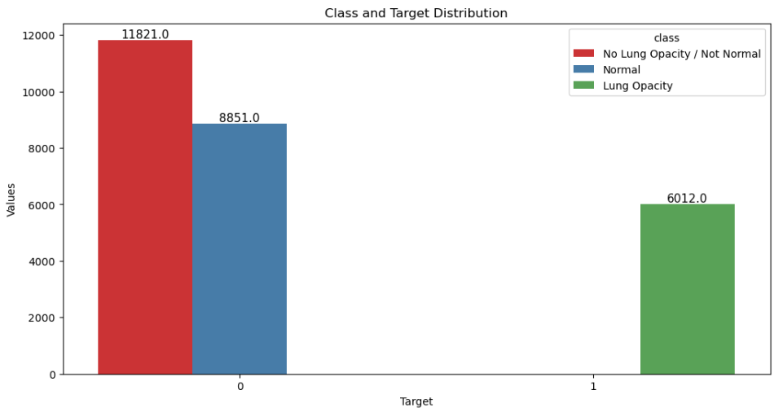

Target = 1 is associated with only one class i.e. **Lung Opacity** whereas Target = 0 is associated with two classes i.e. **No Lung Opacity / Not Normal** and **Normal**.

* + We can see that the centers for the bounding box are spread out evenly across the Lungs. Though a large portion of the bounding box have their centers at the centers of the Lung, but some centers of the box are also located at the edges of lung.

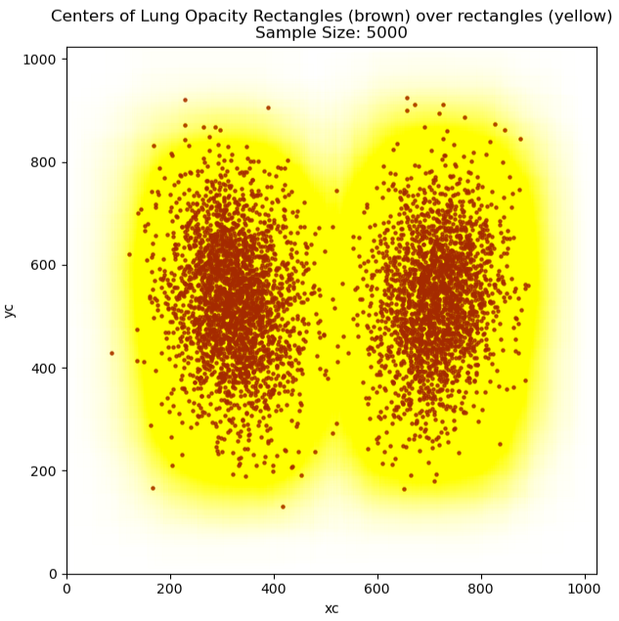

The scatter plot with brown dots shows the areas of inflammation highlighted which needs to be learnt to identify the issues.

* + We can access and manipulate DICOM files using pydicom module. To use the pydicom.

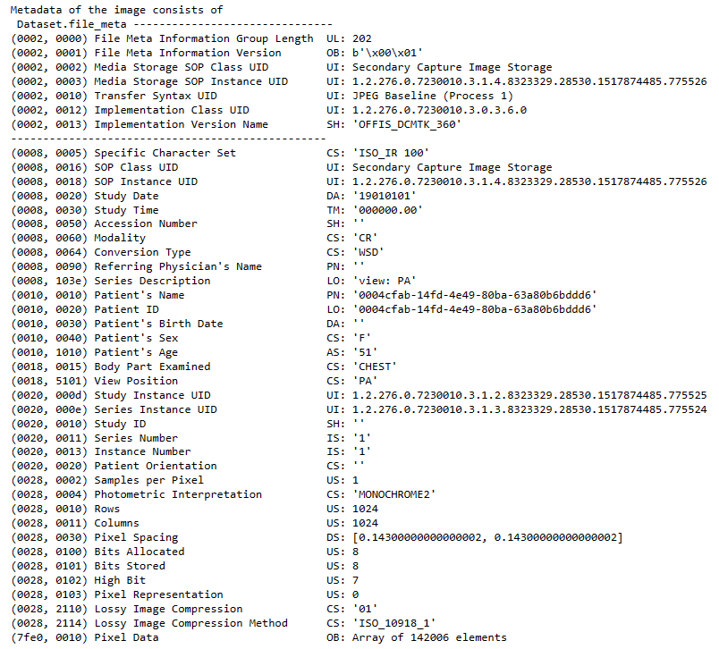

From the above sample we can see that dicom file contains some of the information that can be used for further analysis such as sex, age, body part examined (which should be mostly chest), view position and modality.

We observe all the images are 1024/1024 shape and it needs to be reshaped before feeding them into the model.

* + We can see Patient sex distribution is 43%: 57% [F:M]

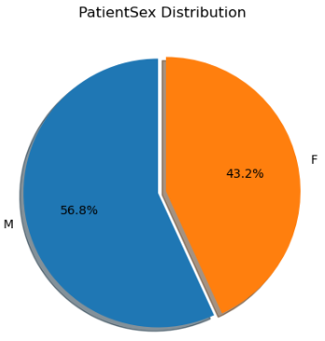

* + Distribution of Patient Sex among the targets

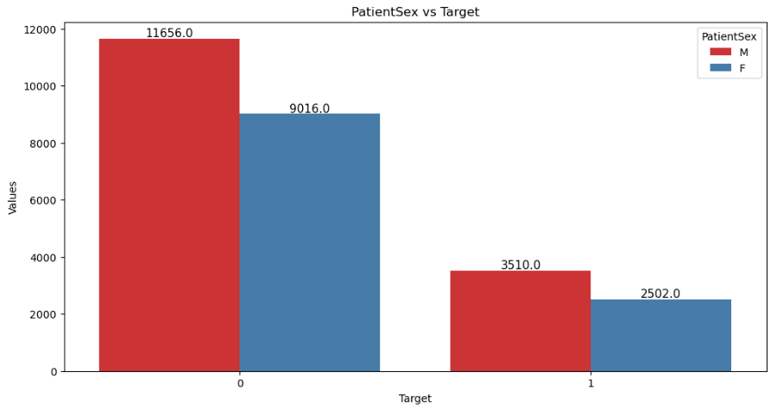

* + Distribution of Sex among the classes

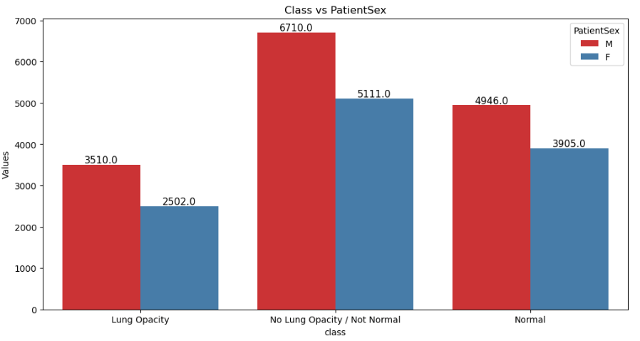

* + Distribution of Sex among the classes

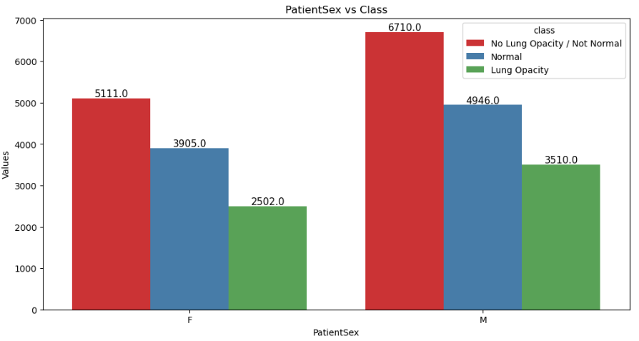

* + Distribution of Patient age among across. We see the spike between 50-60 years

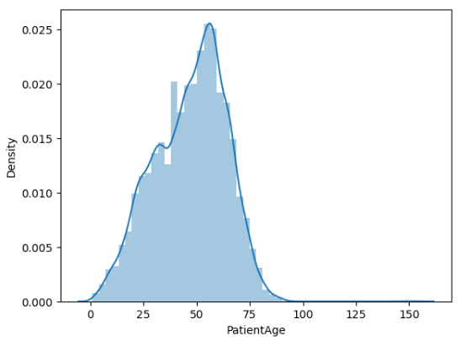

* + Distribution of Patient age across classes.

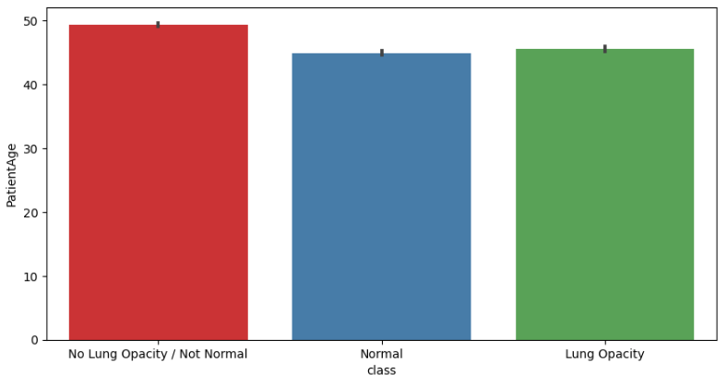

* + Distribution of Patient age across Target.

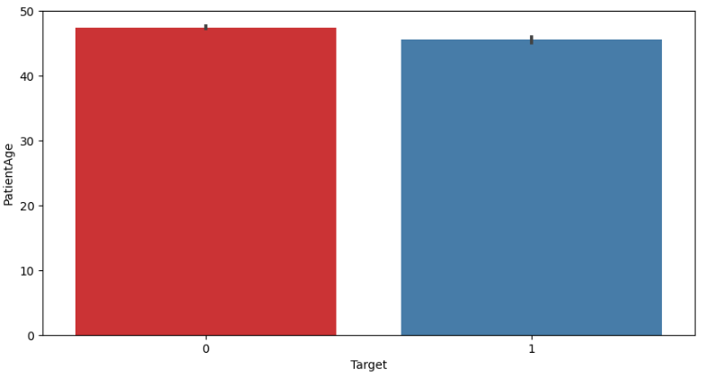

* + We have used DCM images and shown below are the images along with metadata

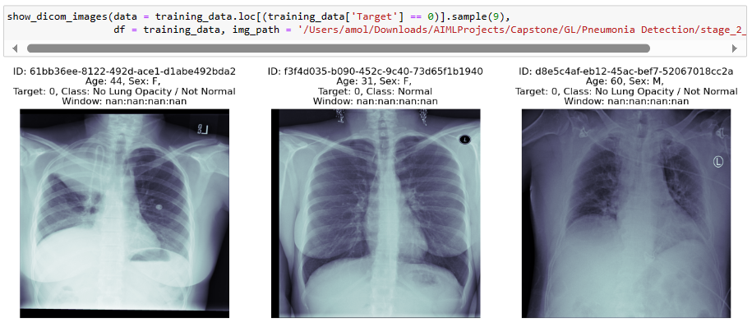

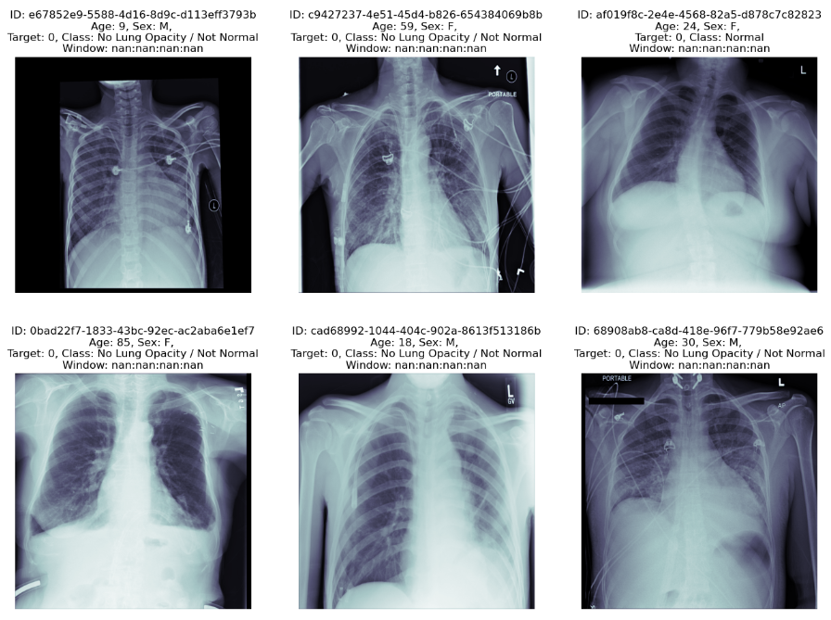

Post this process as part of pre-processing us also associated the proper labelling for the respective images identified for processing further, we also validated this against the total records to make sure that images along with associated labels are properly matched.

* + Below are further depiction of DCM images with bounding box

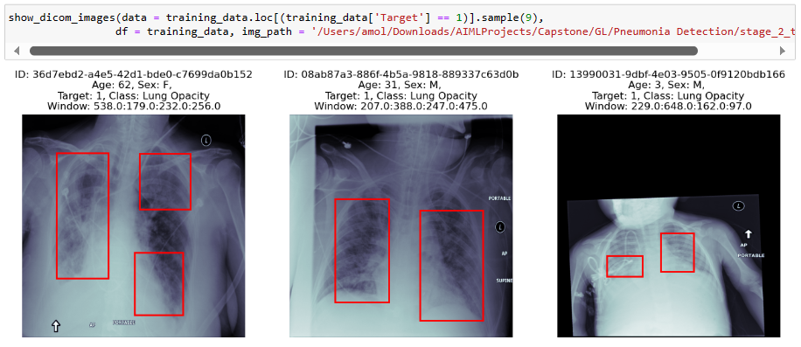

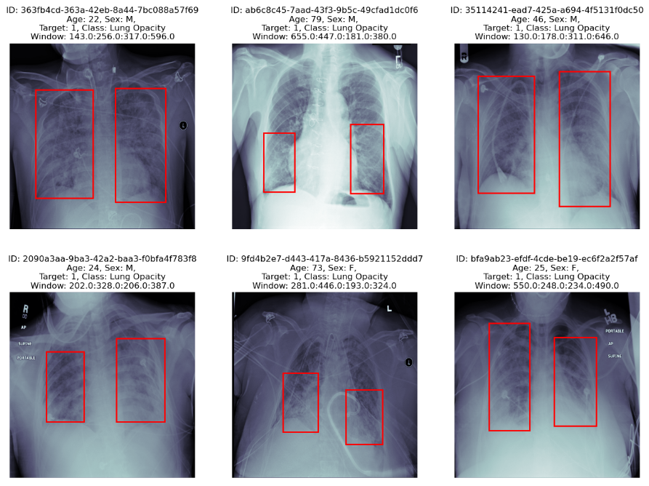

**4. Summary for Interim report**

* The training dataset (both of the csv files and the training image folder) contains information of 26684 patients (unique)
* Out of these 26684 unique patients some of these have multiple entries in the both of the csv files Most of the recorded patient belong to Target = 0 (i.e., they don't have Pneumonia)
* The classes "No Lung Opacity / Not Normal" and "Normal" is associated with Target = 0 whereas "Lung Opacity" belong to Target = 1
* The images are present in dicom format, from which information like PatientAge, PatientSex etc are obtained
* The centers of the bounding box are spread out over the entire region of the lungs.

Next steps: As a team we need to first build basic CNN model

**5. Deciding Models and Model building**

For the interim report, we have constructed a vanilla CNN model for image classification. CNN models have been created from scratch and trained on Chest X-Ray Images (Pneumonia) dataset. Keras neural network library with TensorFlow backend has been used to implement the models. Due to resource limitation, we have taken 500 samples from each class as a dataset. 70% of the dataset is used for Training, 15% as Test and 15% for validation. The images have been resized to 256x256x3 from the original 1024x1024 pixels. Class labels are encoded as 0,1 and 2. ***0 stands for Lung Opacity, 1 stands for No Lung Opacity / Not Normal, 2 stands for Normal***

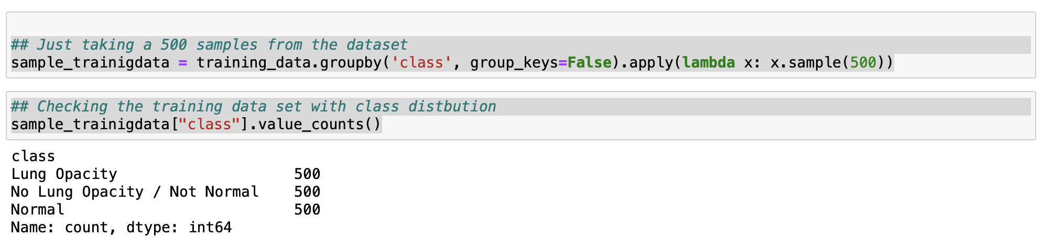



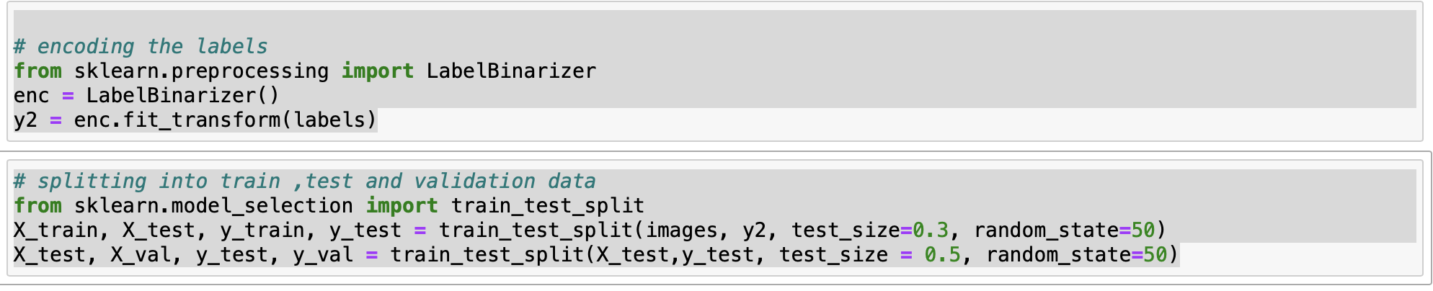

***5.1. CNN Architecture***

We have used sequential CNN Model without transfer learning, we have started with 32 filters with 5,5 kernel and no padding, then 64 and 128 with drop-out layers in between and finally a SoftMax activation as the last layer.

Without Transfer learning, the accuracy is not high but the model is general

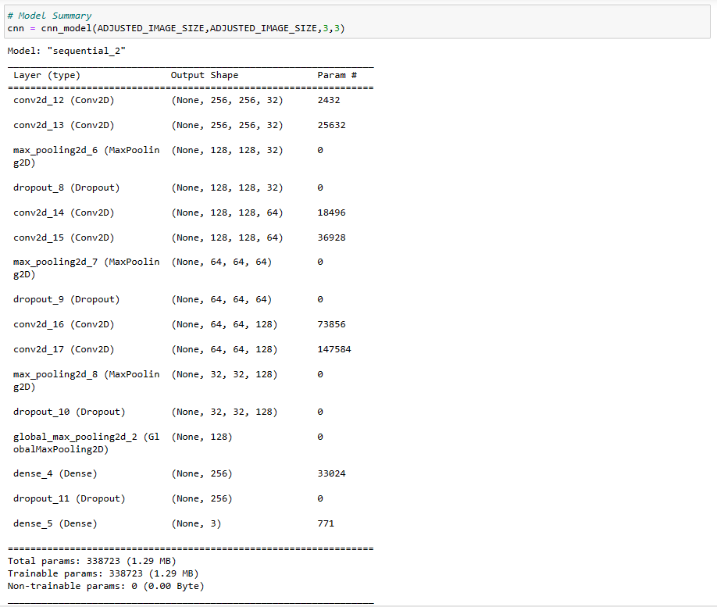

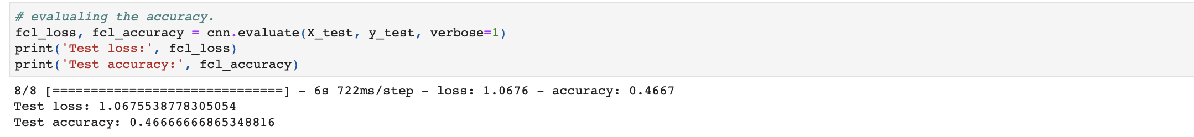

The training and Validation loss is almost same, but for the training and validation accuracy chart

The validation accuracy falls down in the later epochs, this could be because we have only taken 225 images for processing.

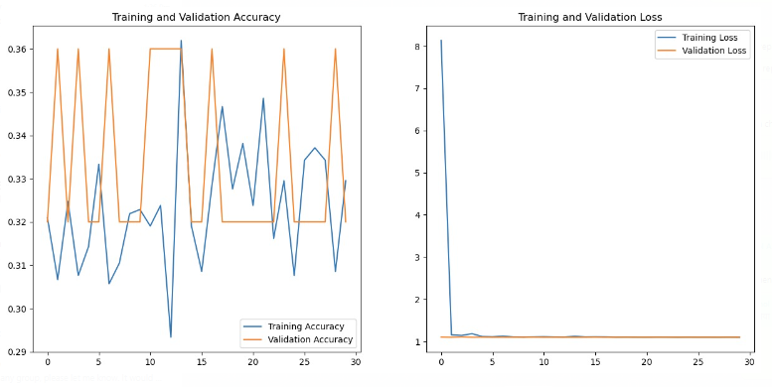

***Confusion Matrix***

* Class 0, 1 and 2
* Class 0 is Lung Opacity
* Class 1 is No Lung Opacity/Normal, the model has predicted mostly wrong in this case to the Target 0. Type 2 error.
* Class 2 is Normal

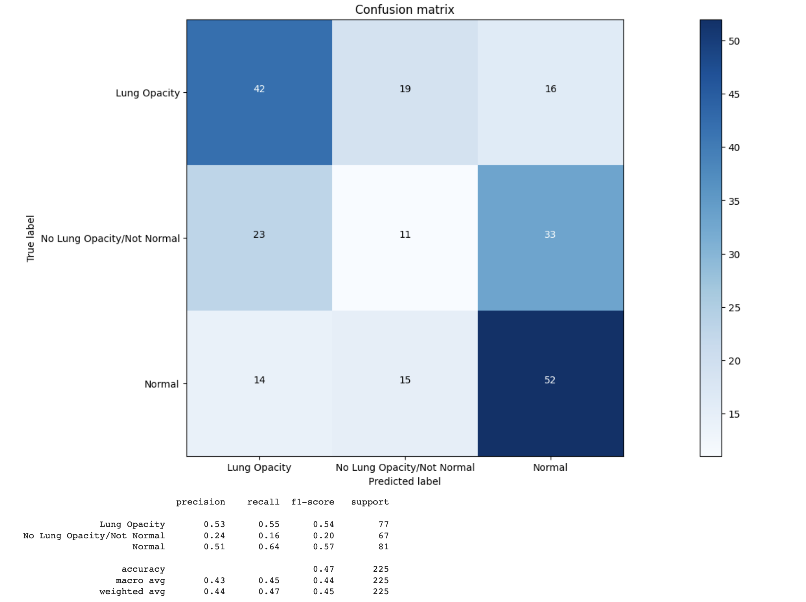

**6. Conclusions**

* The training dataset (both of the csv files and the training image folder) contains information of 26684 patients (unique).
* Out of these 26684 unique patients some of these have multiple entries in the both of the csv files.
* Most of the recorded patient belong to Target = 0 (i.e., they don't have Pneumonia).
* The classes "No Lung Opacity / Not Normal" and "Normal" is associated with Target = 0 whereas "Lung Opacity" belong to Target = 1.
* The images are present in dicom format, from which information like PatientAge, PatientSex, View Position etc are obtained.
* The centres of the bounding box are spread out over the entire region of the lungs. But there are some centres which are outliers.
* Currently with the limited sample data set that we have taken we have found the CNN model without transfer learning was the most general model even though the accuracy was not very high.
* We can try to finetune the model to improve the precision score and the test score and we can try to reduce them by using better layers in CNN or use transfer learning with VGG16 & Resnet50 to improve the model performance

**Milestone 2**: Here we will proceed with fine tuning of basic CNN model and will apply various pre-trained model for applying transfer learning for our classification task.

**Summary of Differences:**

1. **Regularization**: Fine-tuned model introduces L2 regularization to the convolutional layers, which can help prevent overfitting.
2. **Callbacks**: Fine-tuned model uses callbacks during training for adaptive learning rate adjustment, early stopping, and saving the best model weights.

In essence, Fine-tuned model has been fine-tuned with regularization and training callbacks to potentially improve training stability and performance.

Results are as follows

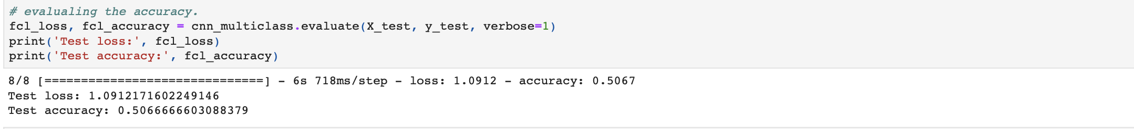

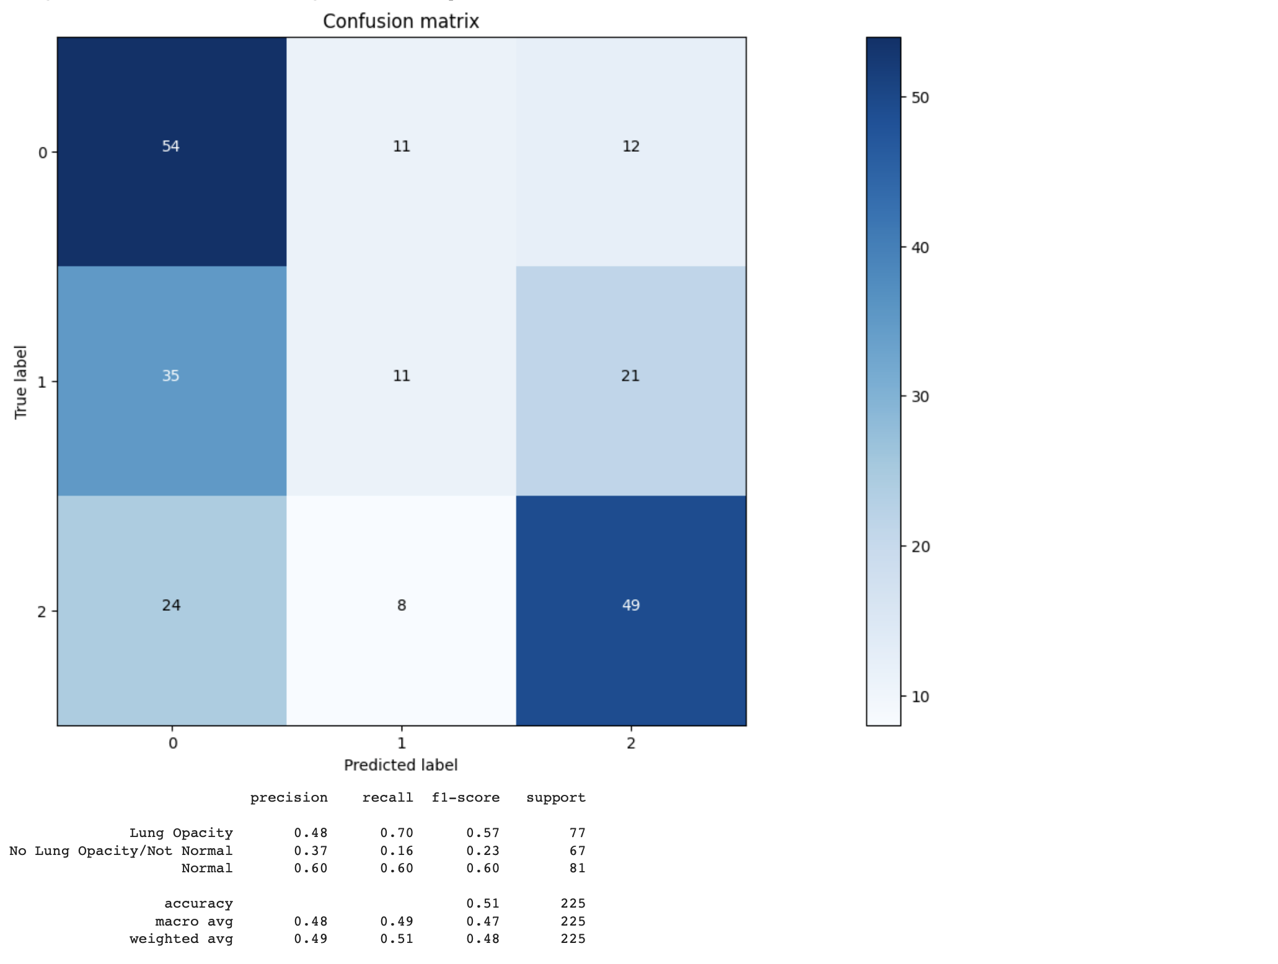 With our basic CNN fine tuning, we were able to increase average accuracy from 44% to 49%. It is significant improvement.

Now we will try few **pre-trained** models.

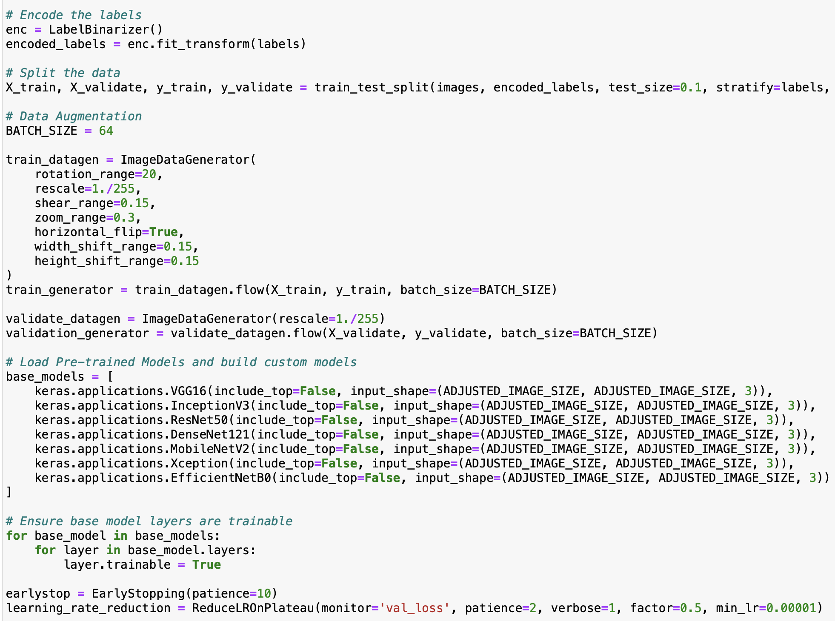

Here we are using VGG16, InceptionV3, RestNet50,DenseNet121,MobileNetV2, Xception and EfficientNetB0 pretrained models. We are using sample of 1200 images here to train our models.  


Models are trained in a for loop with 15 epochs.

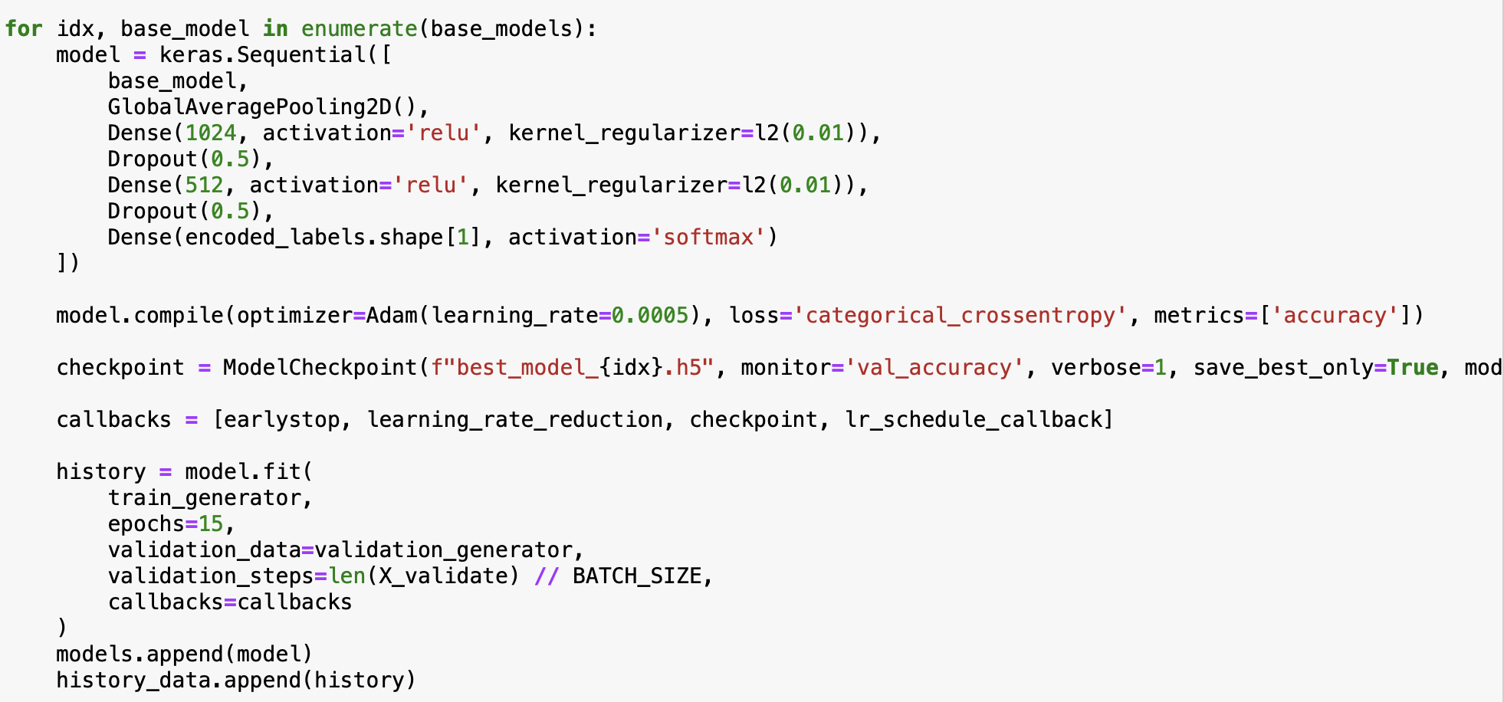

This code initializes a neural network with a base pre-trained model, several dense layers, and dropout for regularization. The models are then compiled, and various callbacks are set up for training. Finally, the models are trained using a training generator and validated using a validation generator. The trained models and its history are stored in lists for potential future use.

Plotting of loss and accuracy for each model

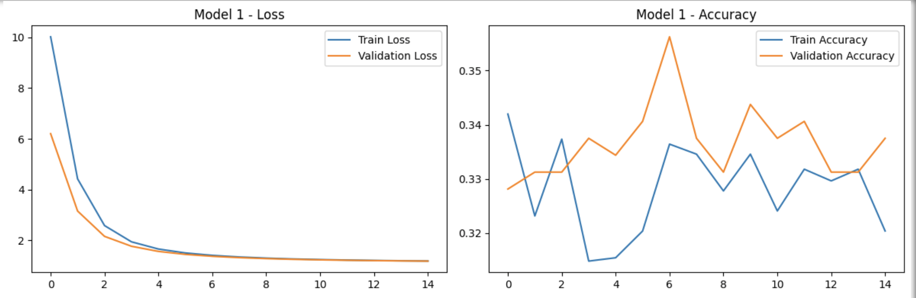

***InceptionV3***

***VGG16***

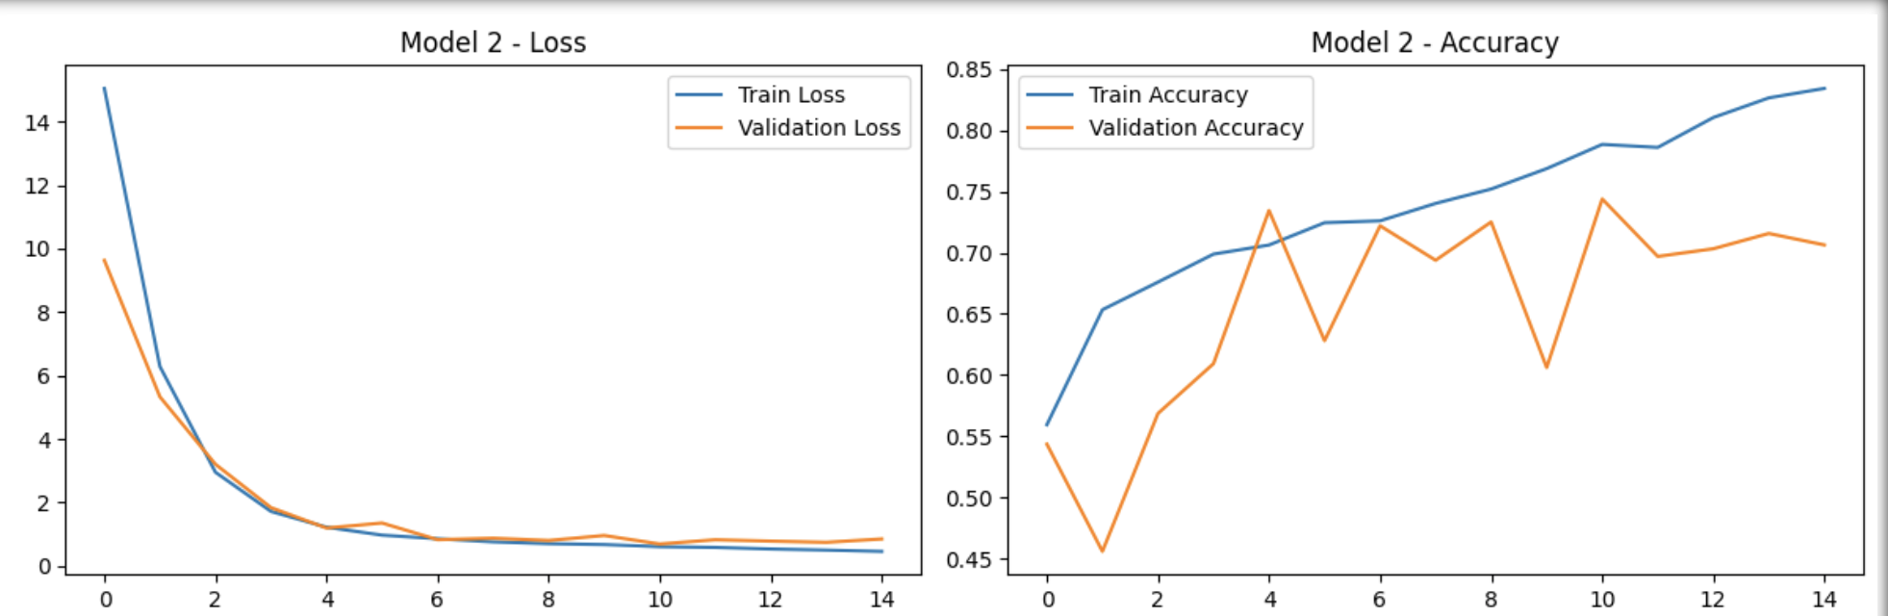

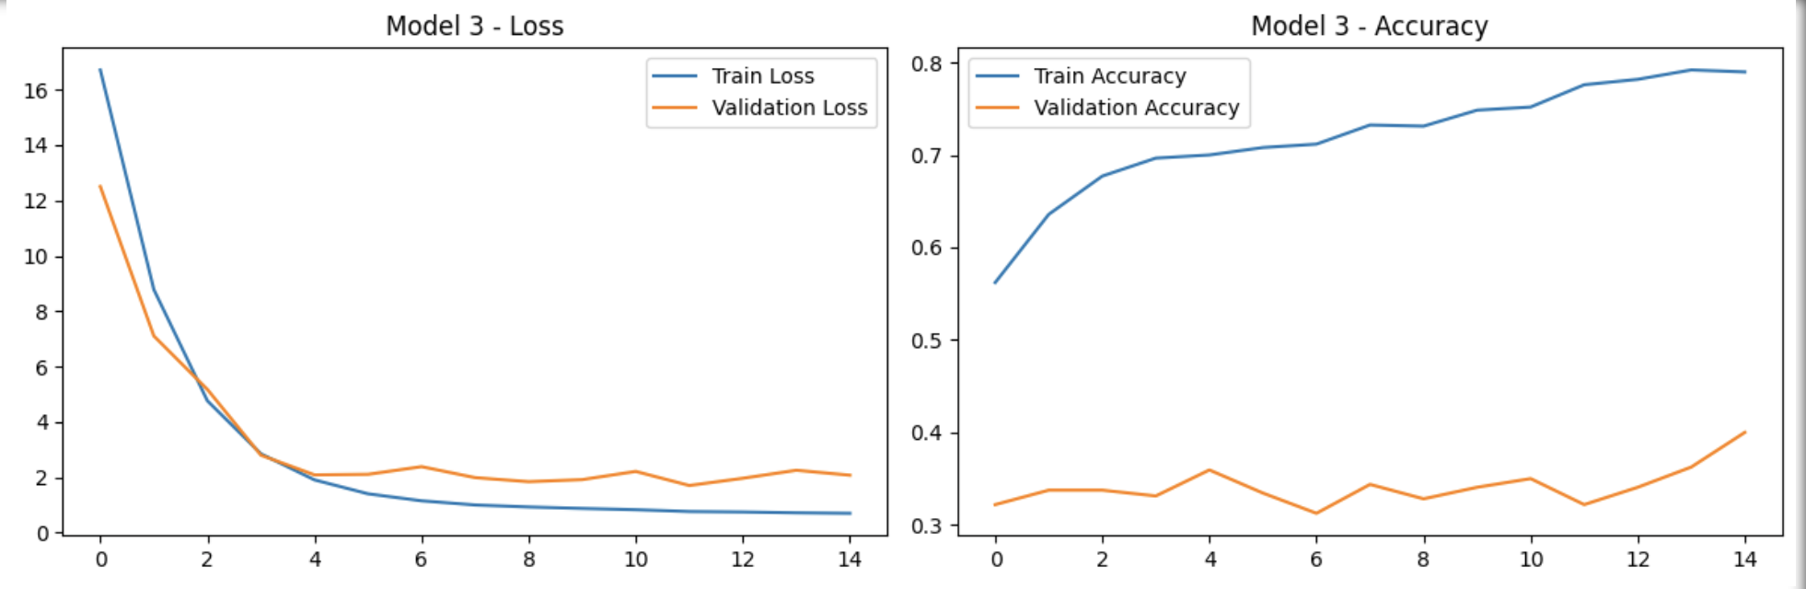

***RestNet50***

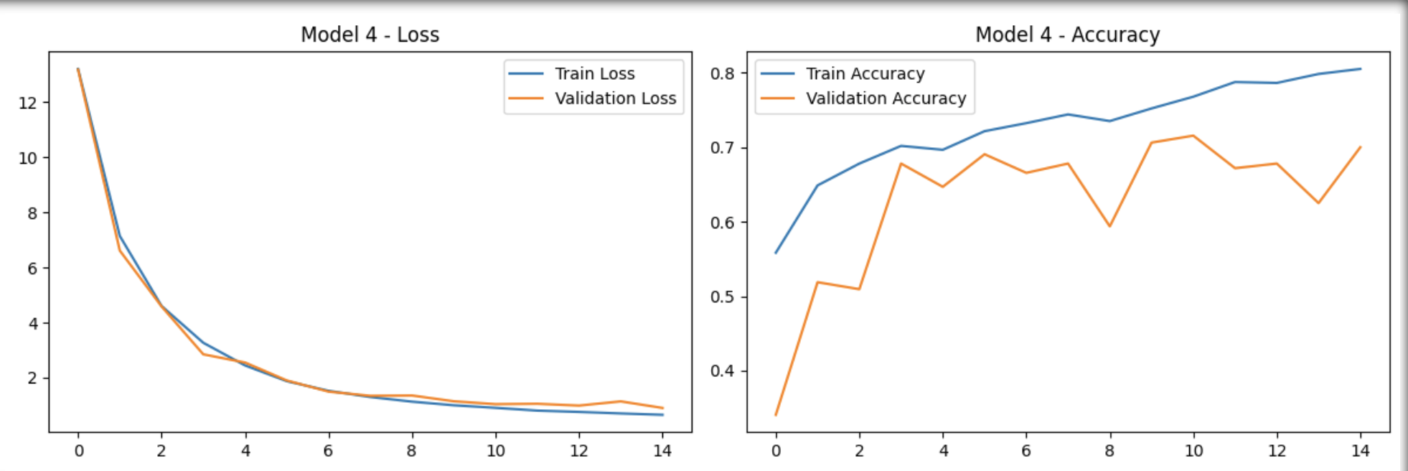

***DenseNet121***

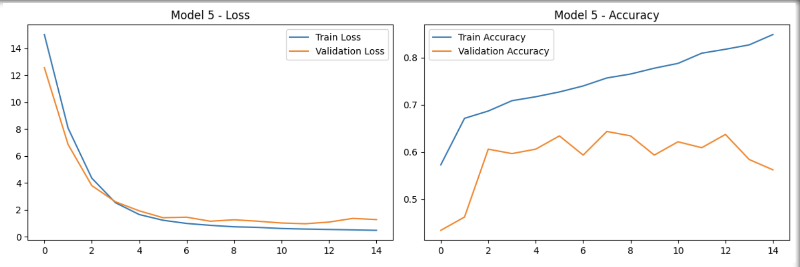

***MobilenetV2***

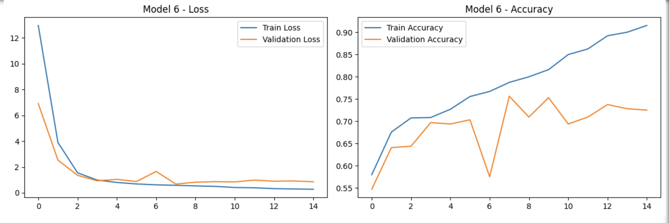

***Xception***

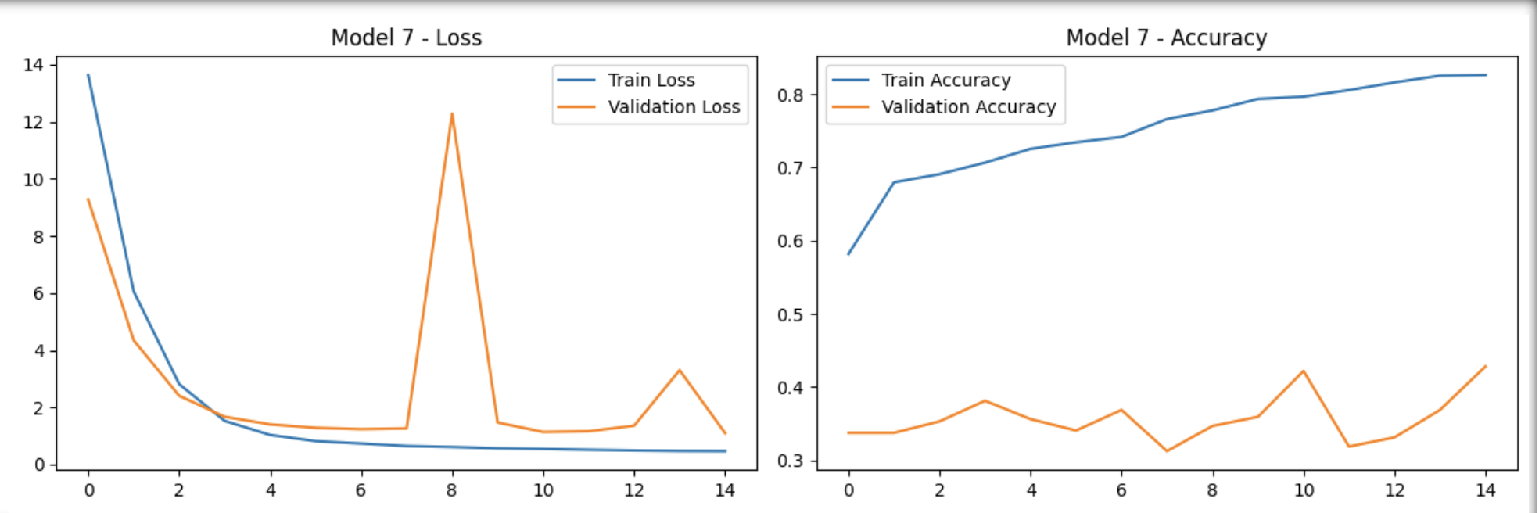

***EfficientNetB0***

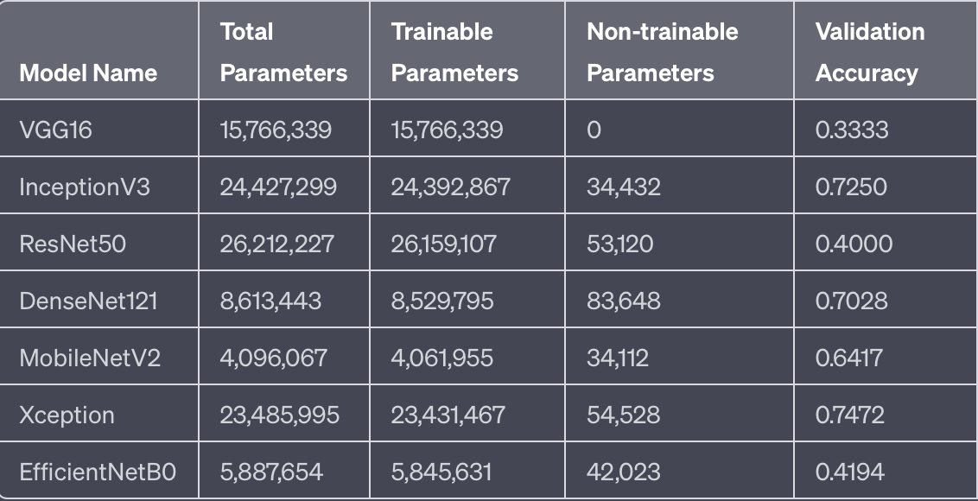

By applying transfer learning, we can see very good progress in accuracy and if further fine tuned these models with larger training images and more epochs with hyperparameter tunning we will get much better prediction results.

Let’s also check how **U-Net architecture** performs as its primarily designed for ***biomedical image segmentation.*** U-Net is a specialized CNN architecture for segmentation tasks, particularly effective in biomedical image segmentation due to its ability to capture features at various scales and provide precise localization.

We have designed model architecture as follows

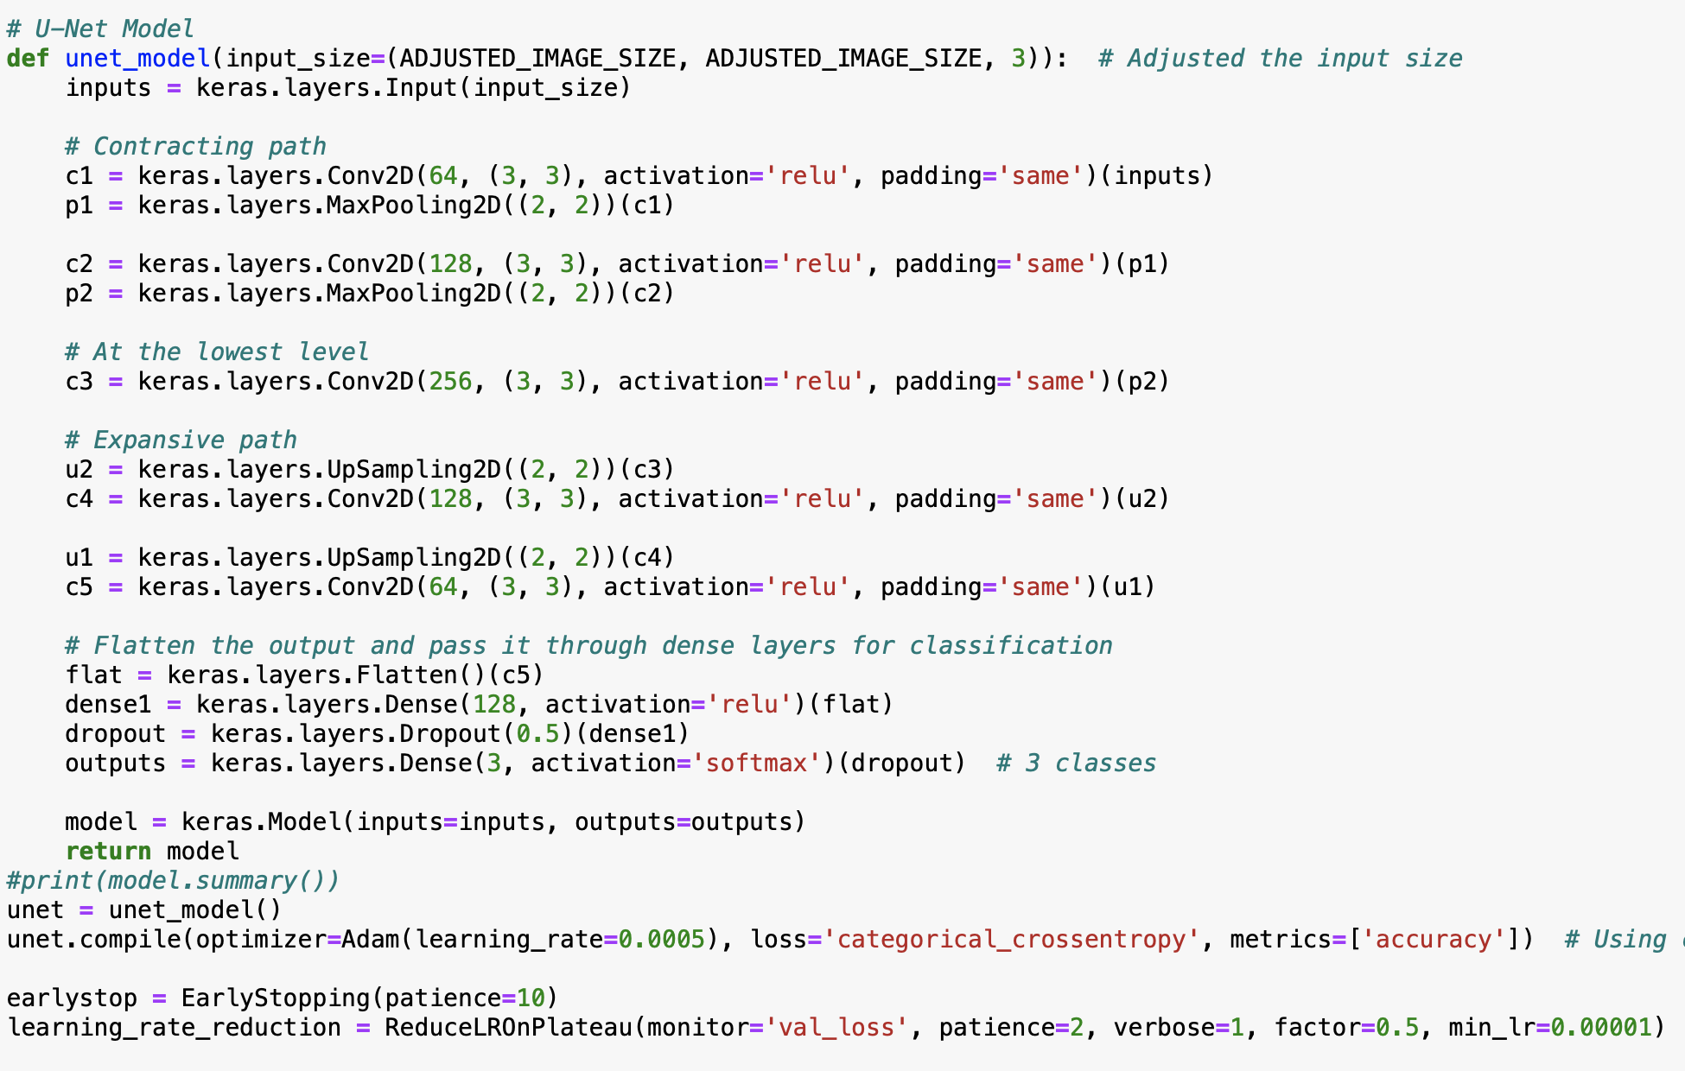

1000 sample images were taken.



And data augmentation was carried out.

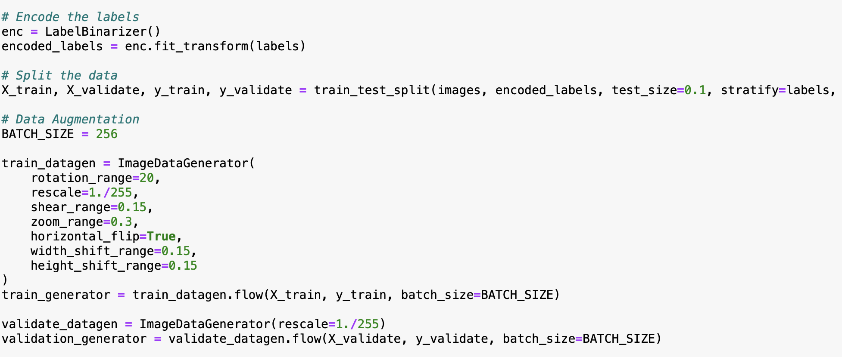

Model was trained for 15 epochs and it was giving very promising results without going into overfitting zone.

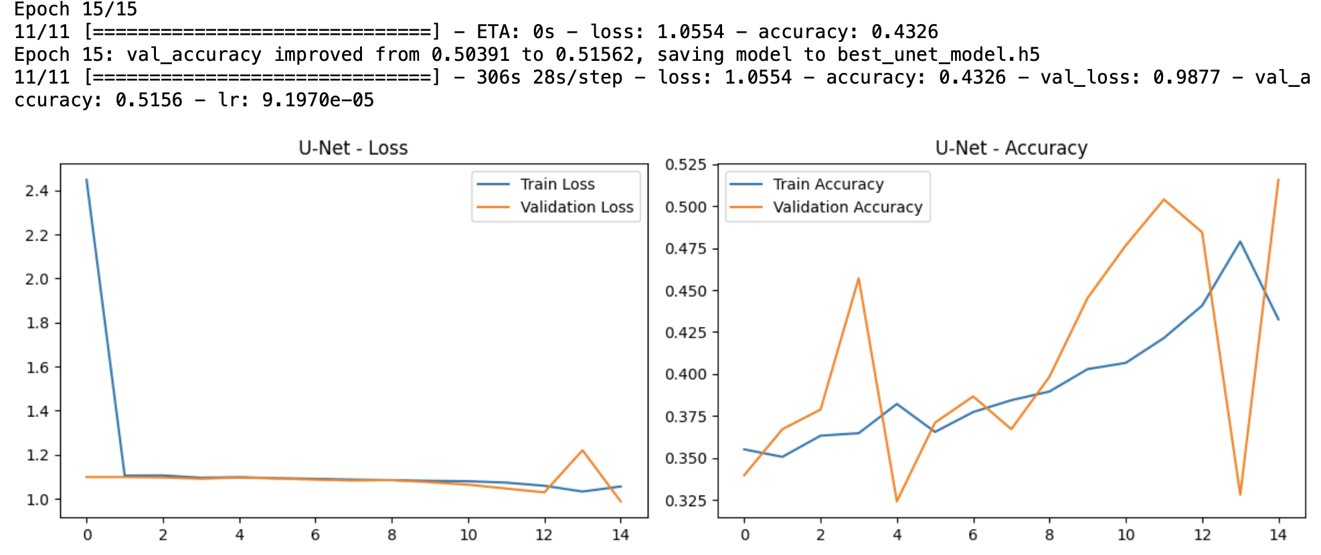

If this model trained further then we can get very good results.

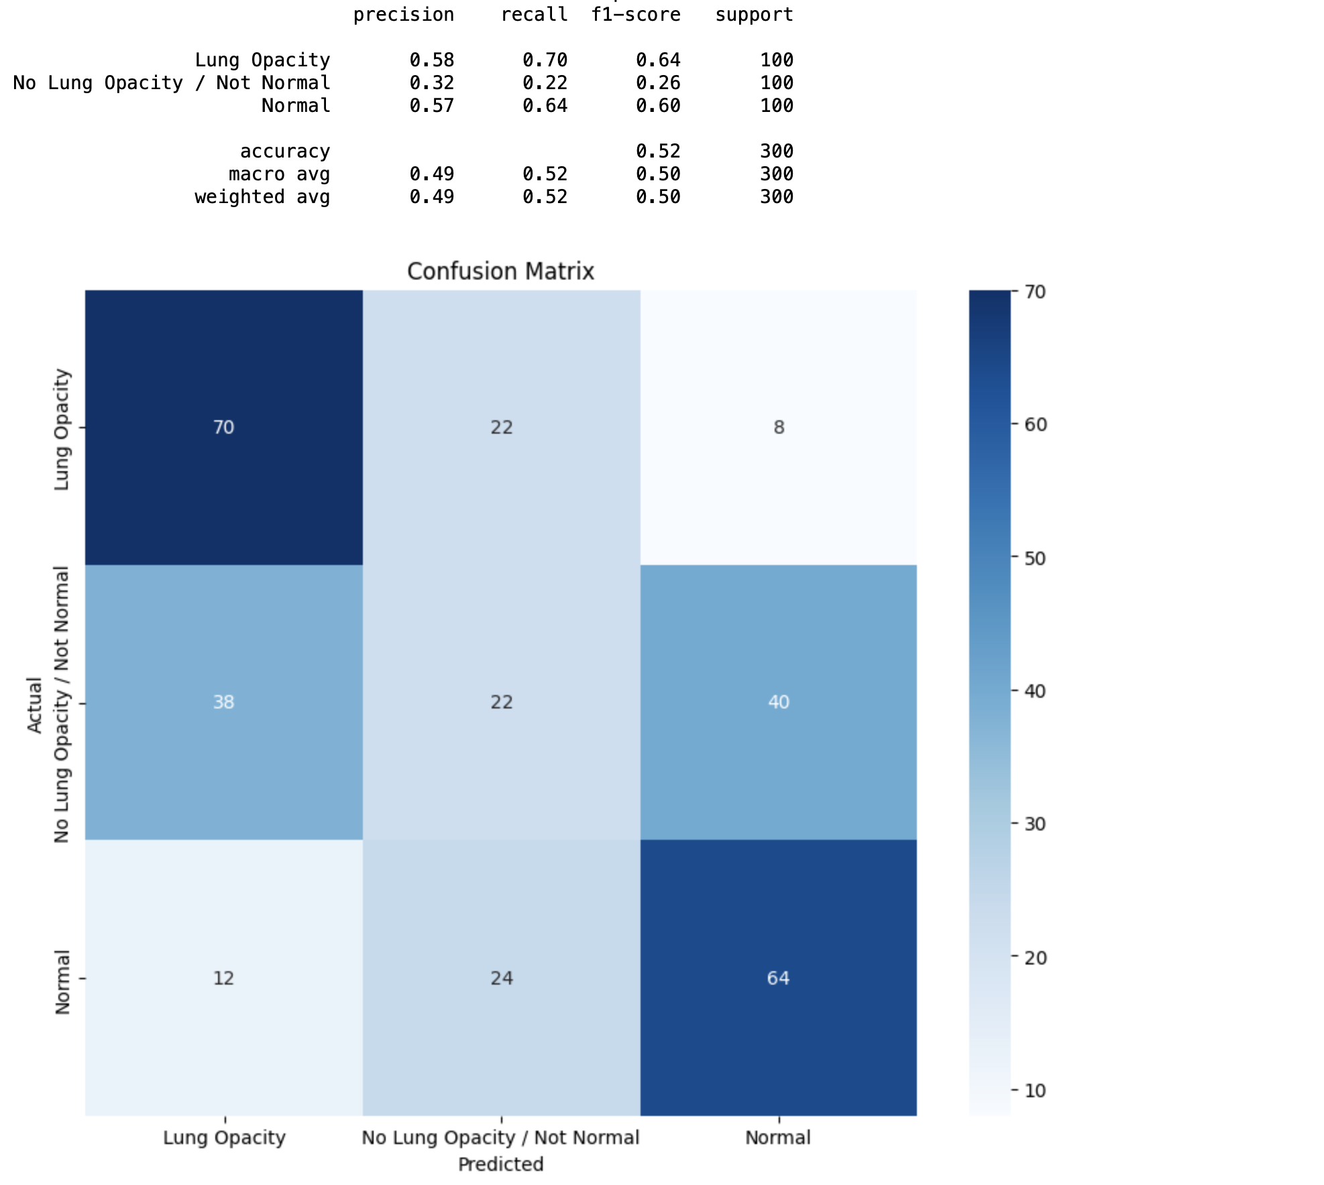

**Customized Deep Convolutional Neural Network for Object detection & Image Segmentation :**

Since U-Net results were promising, its better to use some custom deep convolution neural network that combines U-Net and ResNet Architecture.

Combining the architectural principles of U-Net and ResNet in a custom convolutional deep network can offer several advantages, especially for tasks like image segmentation:

**1. Higher Capacity for Learning:**

- Combining U-Net and ResNet would integrate the strengths of both architectures. While U-Net excels at capturing local and global context, ResNet can deeply model features without degradation. The resulting architecture would have a higher capacity for learning intricate patterns.

**2. Improved Gradient Flow:**

- ResNet's skip connections (or residual connections) alleviate the vanishing gradient problem, ensuring that gradients can flow through many layers without diminishing in magnitude. This makes training deep networks more stable.

- U-Net's skip connections help retain spatial information from earlier layers. When combined with ResNet, this can further enhance the gradient flow, making the training of very deep networks more feasible.

**3. Preservation of Spatial Context:**

- U-Net's expansive path and skip connections ensure that spatial context from the contracting path is retained, which is vital for precise localization in tasks like segmentation.

- By integrating ResNet's residual blocks, the network can leverage deep representations while maintaining spatial context, leading to more accurate segmentations.

**4. Robustness to Overfitting:**

- Residual connections in ResNet introduce a form of regularization. By allowing certain paths for the data to flow without any transformation, it can prevent overfitting to some extent.

- U-Net's structure, especially with the expansive path, can further reduce the chances of overfitting by leveraging spatial hierarchies.

**5. Flexibility in Design:**

- A custom network allows for flexibility in design choices. For instance, one could use bottleneck blocks from ResNet in the contracting path of U-Net or adjust the number of layers and channels based on the problem's complexity and available data.

**6. Enhanced Feature Learning:**

- ResNet's depth and residual learning capability allow for the extraction of a rich set of hierarchical features. When combined with U-Net's ability to merge features at various resolutions, the network can recognize and differentiate between complex patterns more effectively.

**7. Efficient Training:**

- ResNet allows for the training of deeper models without the traditional issues associated with deep networks, such as vanishing or exploding gradients. When combined with U-Net, the overall architecture can be trained efficiently, even if it's very deep.

In summary, a custom convolutional deep network that combines U-Net and ResNet would benefit from the spatial context preservation of U-Net and the depth and robustness of ResNet. This hybrid model could offer superior performance, especially in tasks that require both deep feature learning and precise spatial localization, such as medical image segmentation.

As the dataset is too large to fit into memory, we have created a generator that loads data on the fly, the generator takes in some filenames, batch size and other parameters. We have used training samples of 18694 images and valid samples of 8000 images

Apart accuracy and key Evaluation metrics used is Intersection over Union (IoU), which is also known as the Jaccard index, is the most popular evaluation metric for tasks such as segmentation, object detection and tracking.

Object detection consists of two sub-tasks: localization, which is determining the location of an object in an image,and classification, which is assigning a class to that object

For model creation, we have defined the batch size as 128 with Image size of 128.

Further we have used Cosine Annealing, which is a type of learning rate schedule that has the effect of starting with a large learning rate that is relatively rapidly decreased to a minimum value before being increased rapidly again.

We have created the train and validation generators.

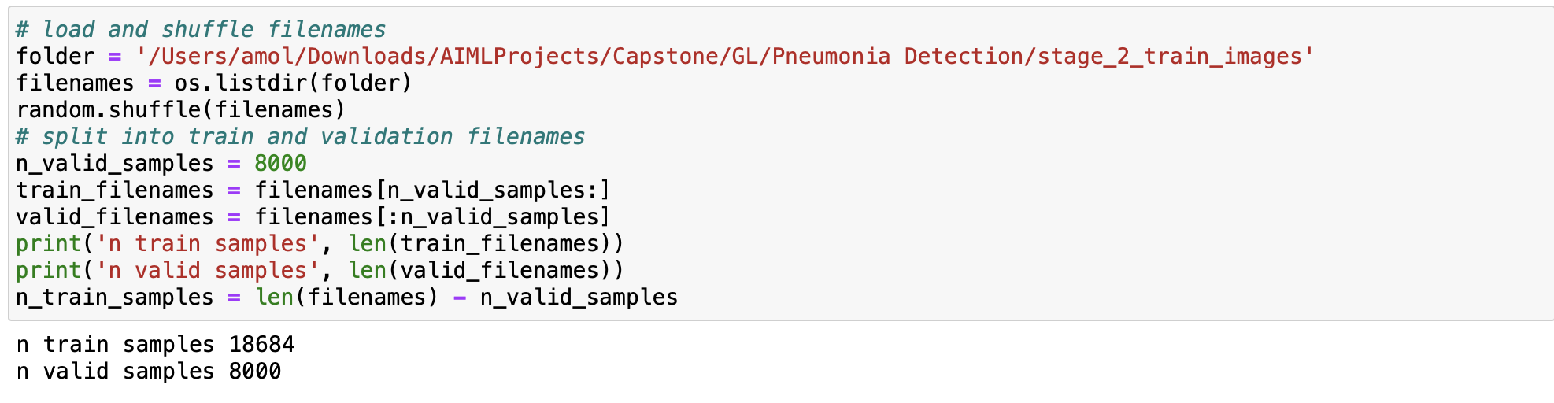

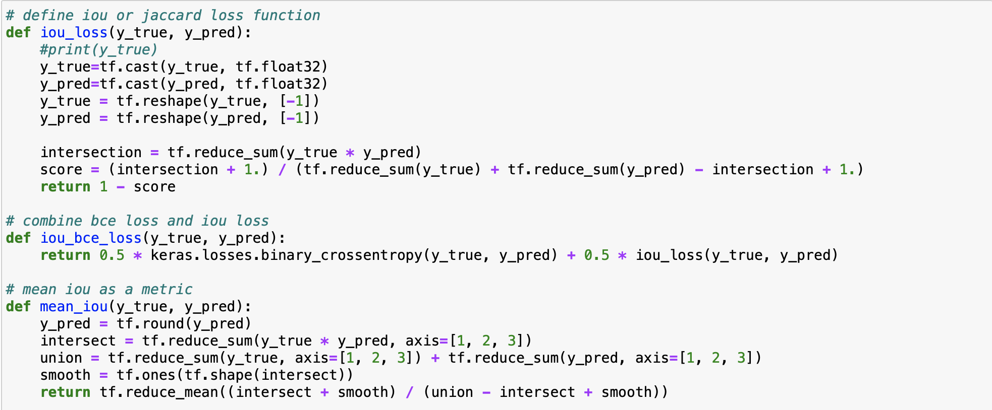

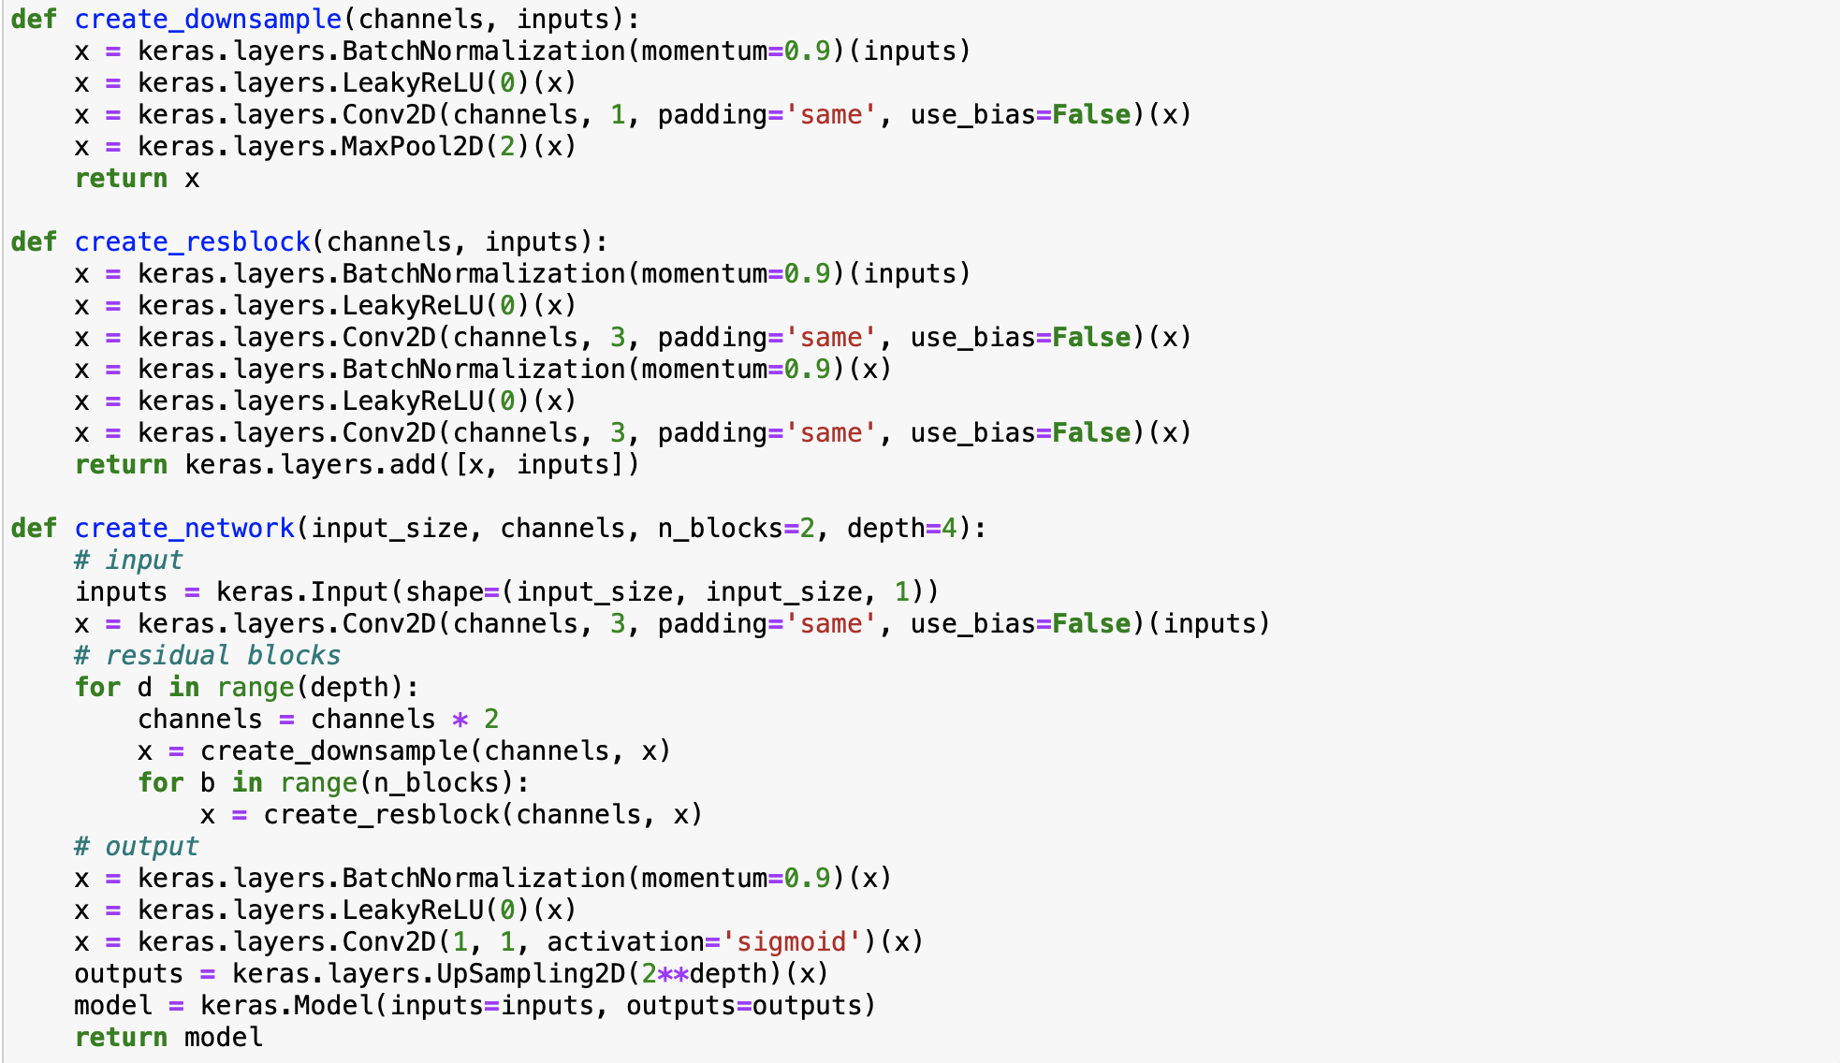

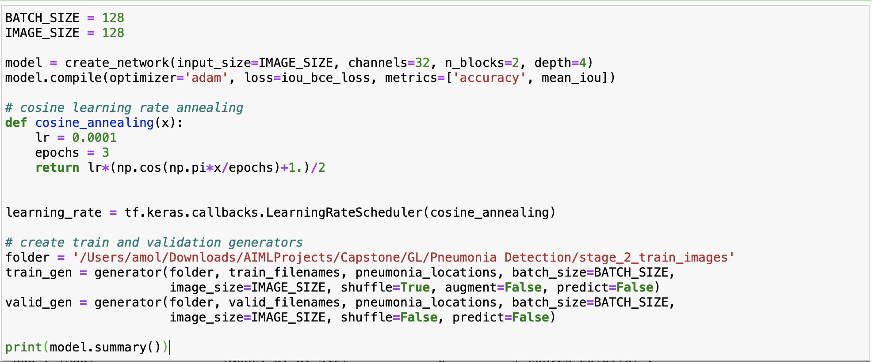

Detailed model Summary is available in ipynb /html file for further inspection.

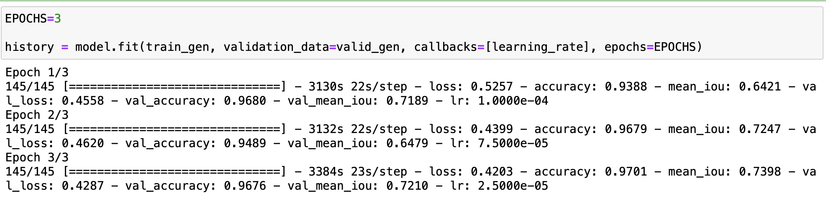

The custom architecture, a blend of U-Net and ResNet, was trained over three epochs. From the first to the third epoch, training accuracy improved from 93.88% to 97.01%, and the Mean Intersection over Union (IoU), crucial for segmentation, rose from 64.21% to 73.98%. Validation accuracy remained high, around 95-97%, but the validation IoU experienced a dip in the second epoch before recovering in the third. The decreasing learning rate indicates a scheduled strategy.

**In the context of image segmentation**:

A high IoU value means the predicted segmented areas closely match the actual areas, indicating precise segmentation. The consistent validation accuracy and the recovered IoU in the third epoch suggest that this custom architecture effectively captures intricate patterns and boundaries in images, making it proficient for image segmentation tasks.

**Implication for Image Segmentation and Object Detection**:

The high accuracy indicates that the model is effectively classifying images as pneumonia or non-pneumonia. The Mean IoU, which is crucial for segmentation, suggests the model is also successful in accurately segmenting the affected regions in the X-ray images. This combined capability is essential for both detecting the presence of pneumonia and precisely delineating its boundaries, which is crucial for clinical diagnosis and treatment planning.

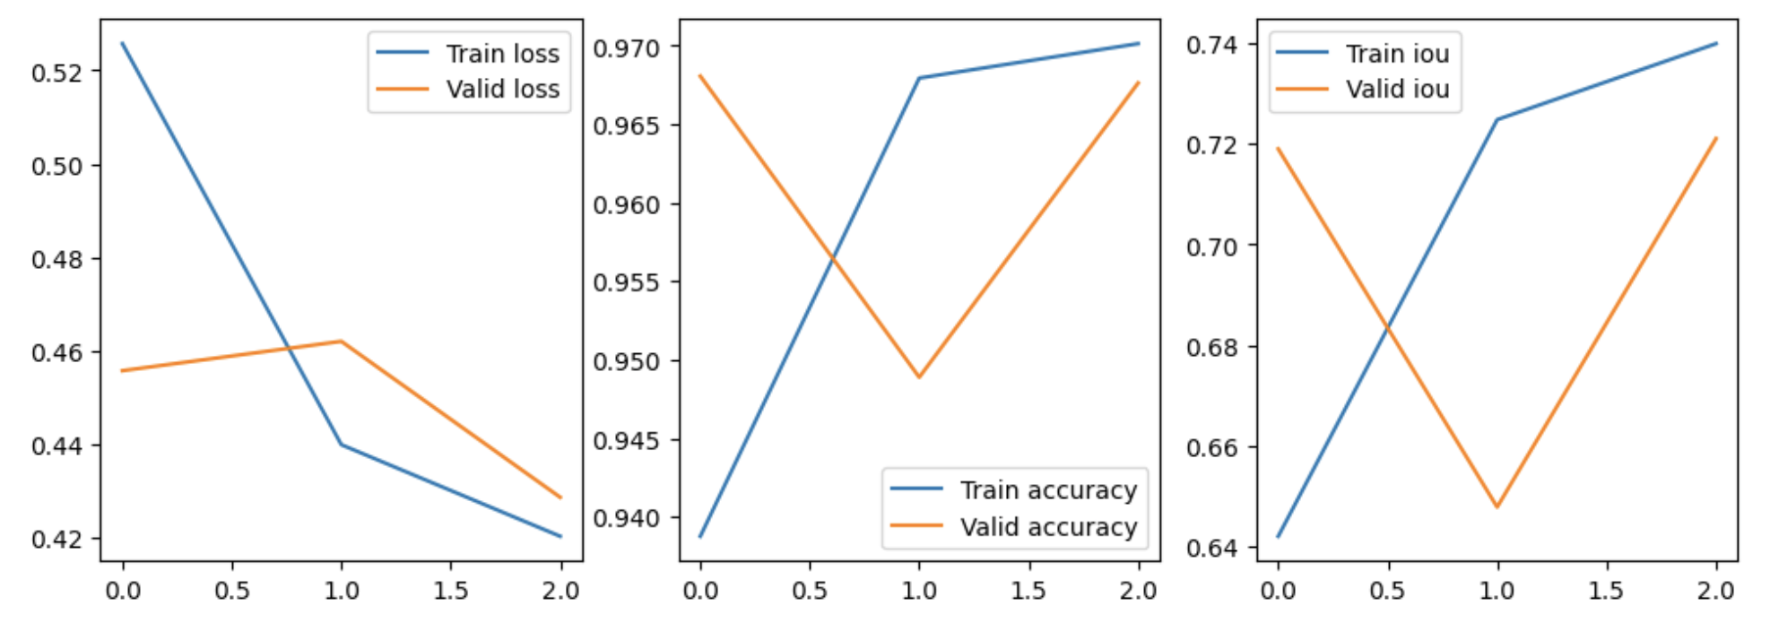

Finally, used the model we have trained to predict the output using the validation generator.

We have achieved accuracy of 95-96% with validation loss of 0.4. IOU was higher greater than 74%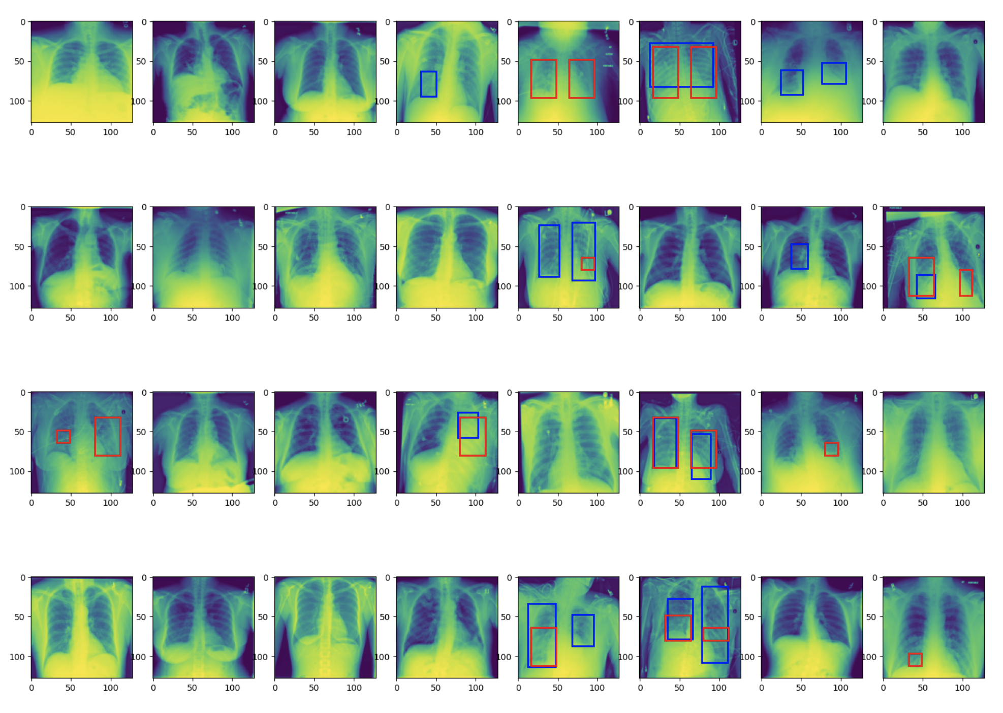

*The key objective of the project is to build an automated pneumonia detection system to locate the position of inflammation in an image.*

After the model training for final predictions, we are getting good accuracy of 95-96% wherever there is pneumonia, with validation loss of 0.4. IOU was higher greater than 65%. Higher the IOU, better the results. While the overall results are good, this can be used as baseline model for any further fine-tuning to get an aspiration for1 IOU

As the baseline model is built using open-source code platform, it can help healthcare specialists to semi-automate the process of detecting pneumonia in lung images. With the current model, it can detect pneumonia with ease but with a certain degree of variance. The precise area needs to be further investigated by the healthcare specialists though as the predicted area might be too large or not accurate enough. Also, there will be many false positives generated as well as the current model predicts smaller pneumonia bounding boxes in images where there is no pneumonia detected.

**Design, train and test Faster RCNN for object detection models to impose the bounding box the area of interest**

Faster R-CNN is an advanced object detection model that employs a deep convolutional network (like ResNet) as its backbone to extract feature maps from the input images. It introduces the Region Proposal Network (RPN) to generate region proposals directly from the feature maps, making it faster and more efficient. These proposals are then resized using RoI (Region of Interest) pooling and are passed through a classifier and a regressor for object classification and bounding box regression, respectively.

**Our Approach was as follows**:

1. **Data Preparation**:
   * Loaded and preprocessed chest X-ray images. This includes normalization and resizing of images and bounding boxes.
   * Prepared labels for Region Proposal Network (RPN) based on the overlap of anchor boxes with ground truth bounding boxes.

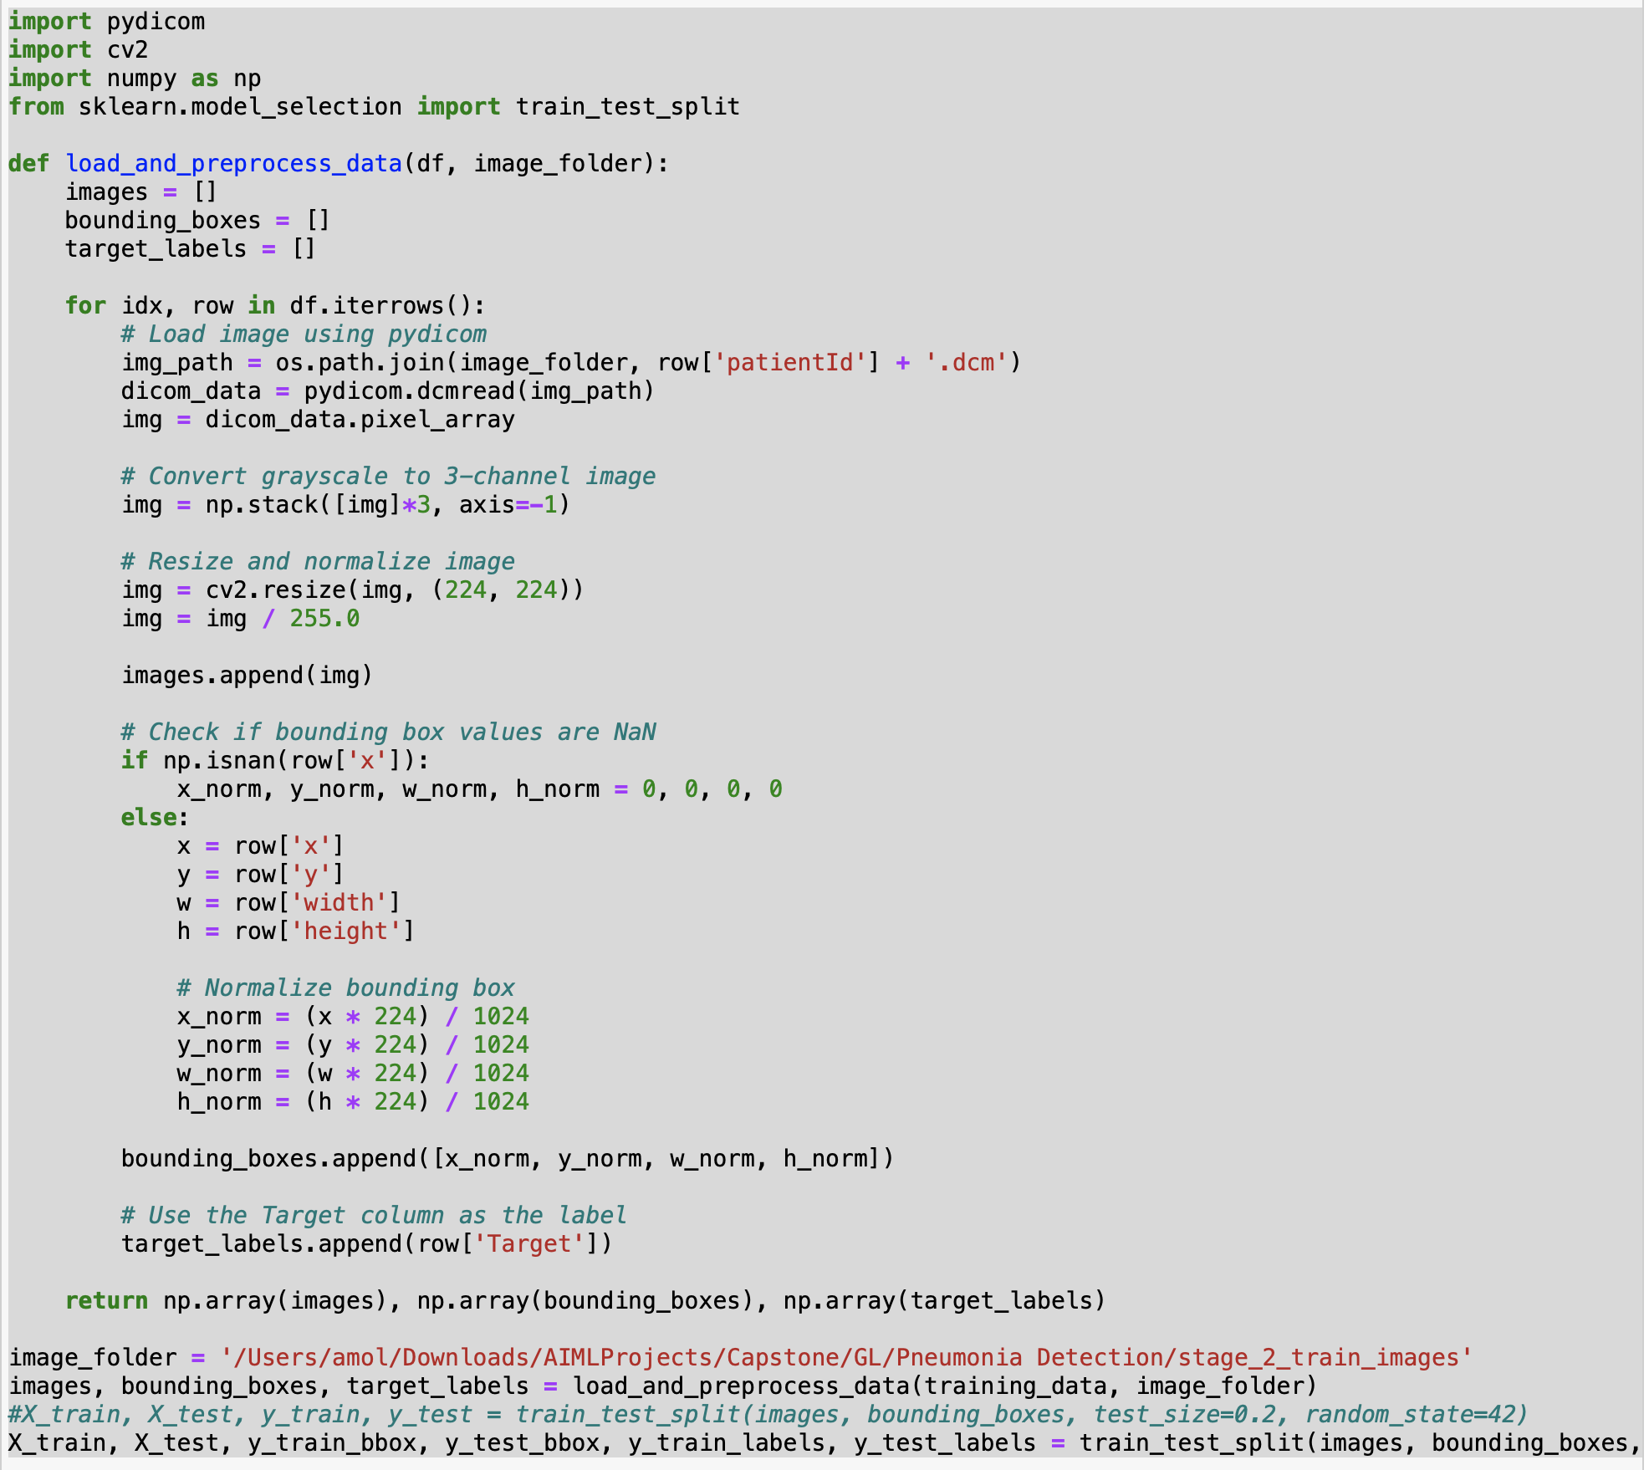

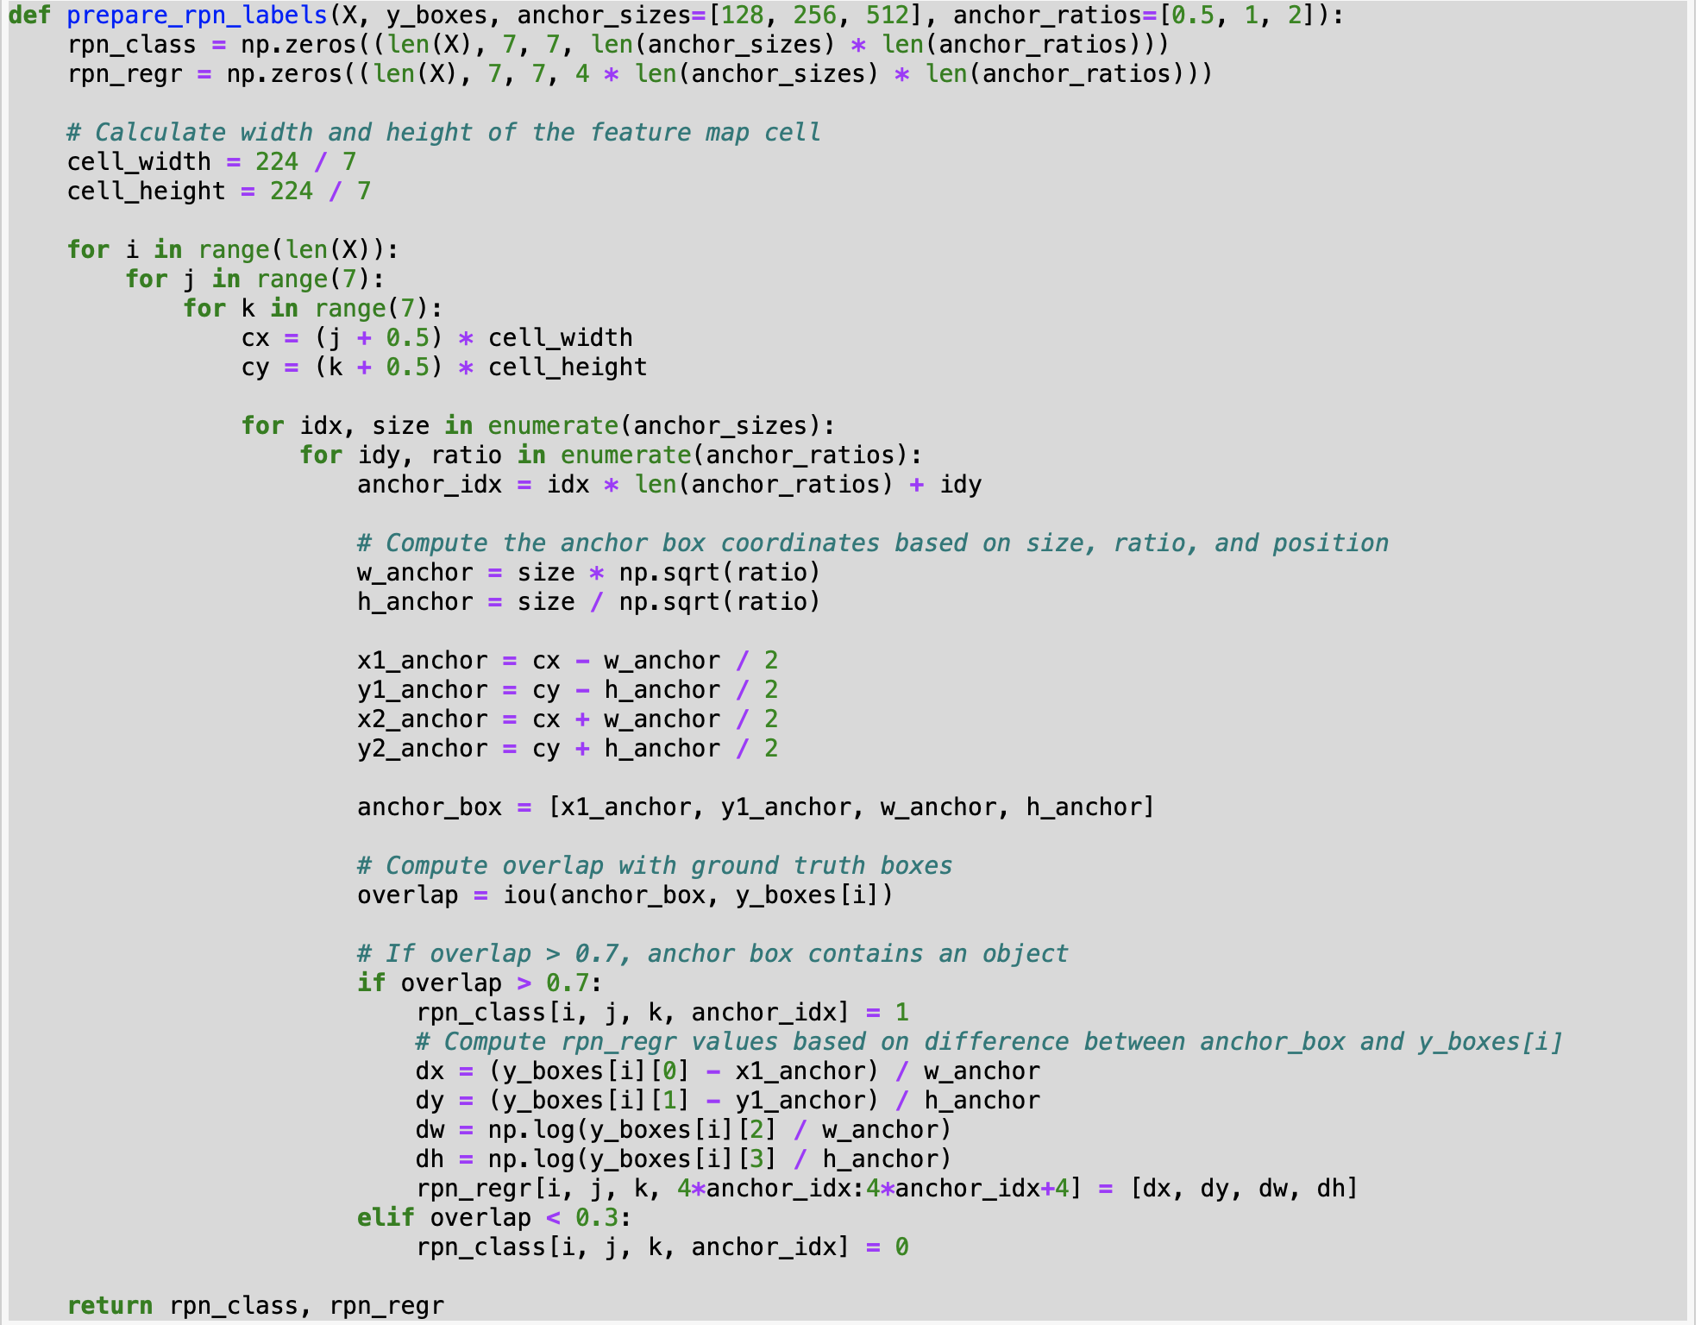

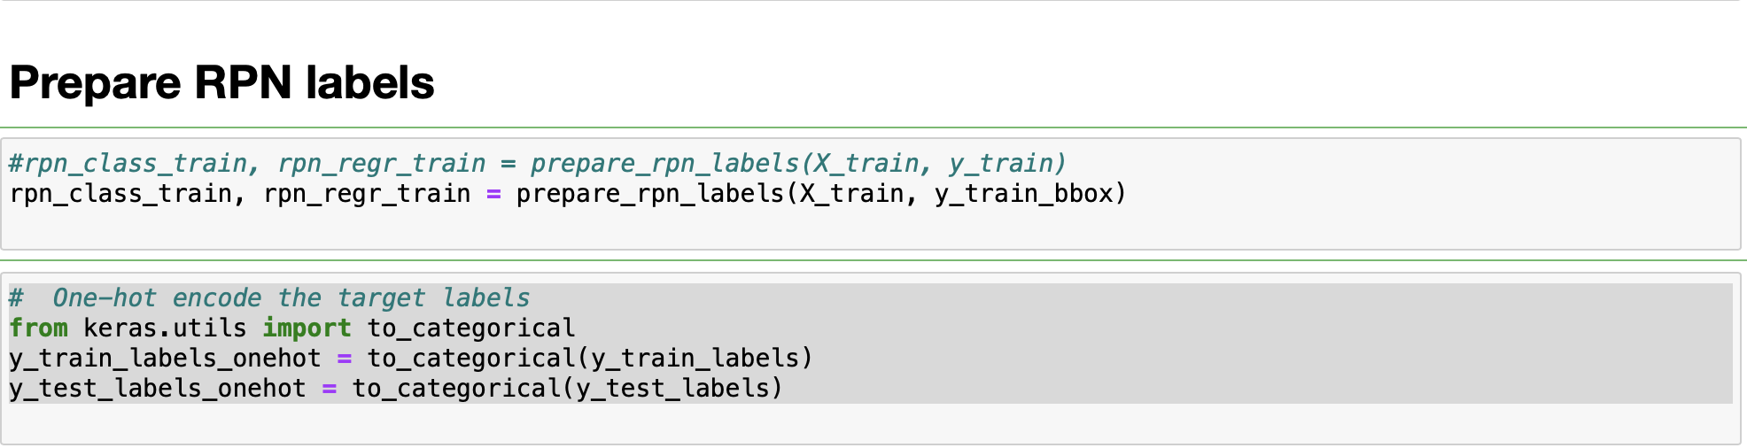

1. **Model Construction**:
   * Employed ResNet50 as the backbone for feature extraction.
   * Built the RPN to generate class scores and bounding box coordinates for each anchor box.
   * Added a placeholder for RoI pooling.
   * Constructed a classifier and a regressor for final object classification and bounding box regression.

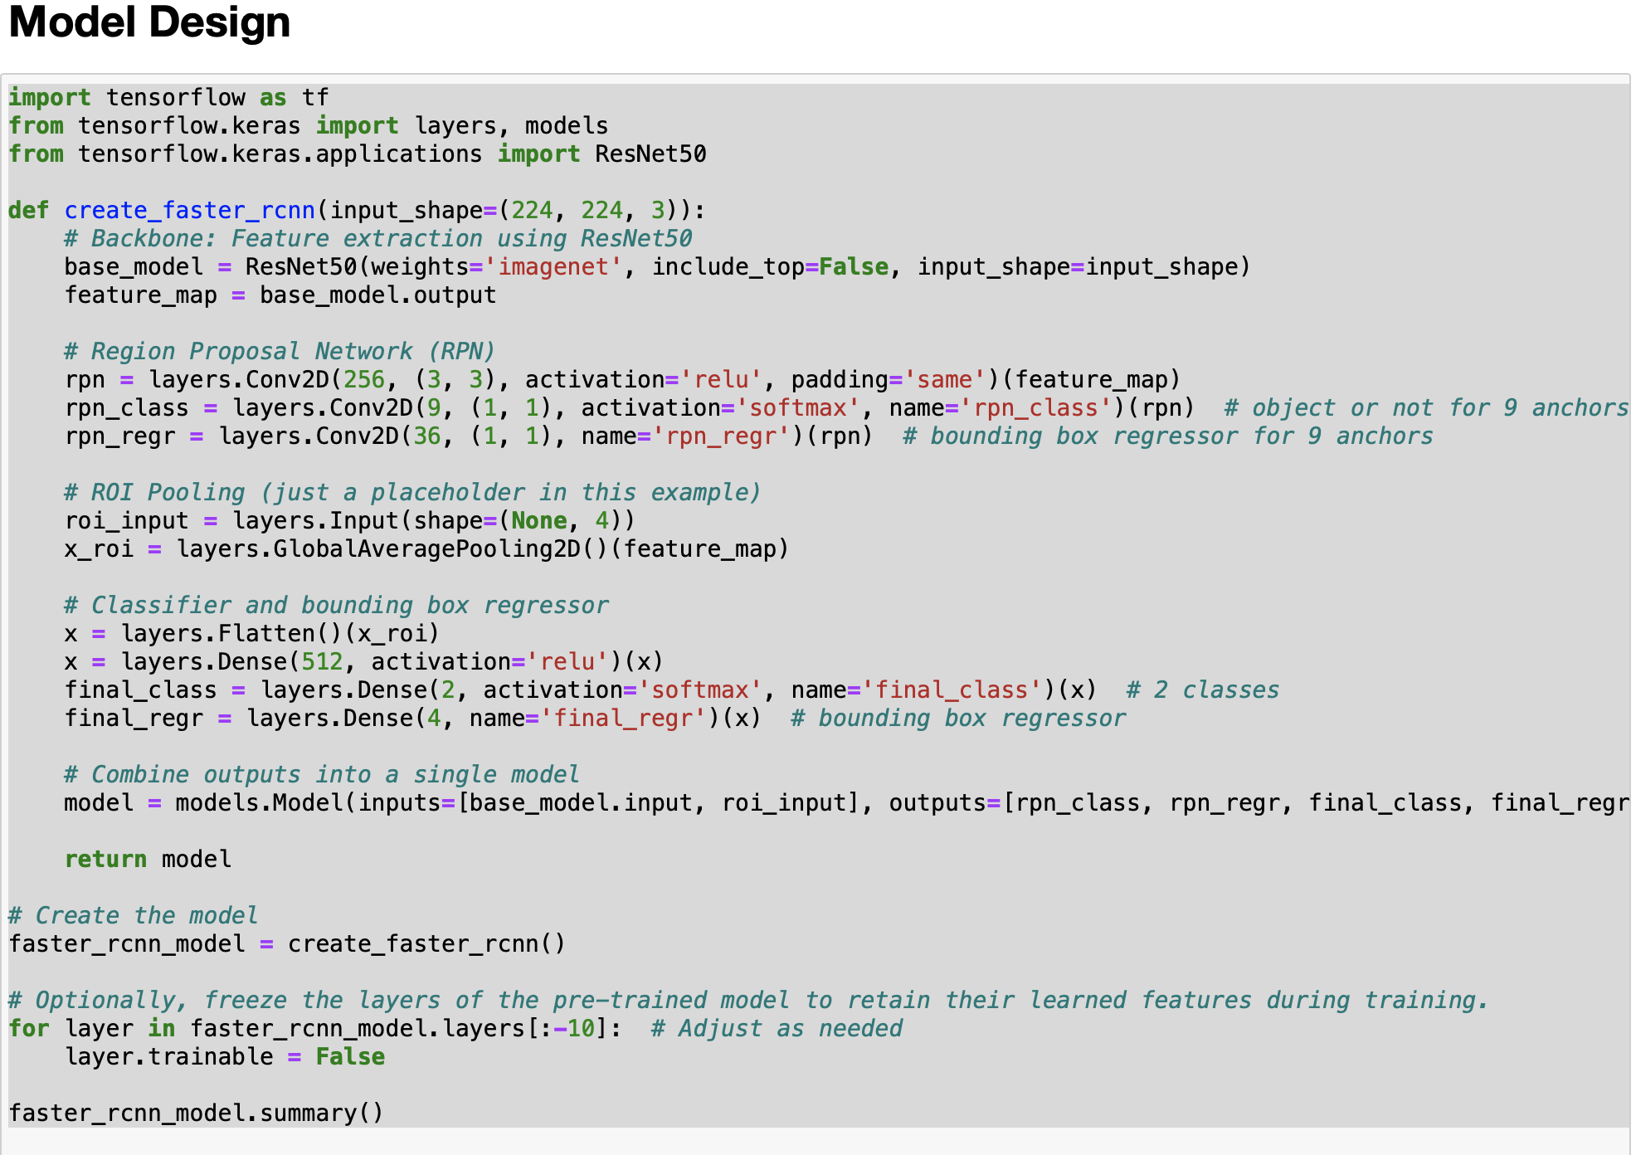

1. **Training**:
   * Customized loss function (IoU loss) to ensure the predicted bounding boxes closely match the ground truth.
   * Created a data generator to feed batches of images and their RPN labels to the model.
   * Employed callbacks for model checkpointing, early stopping, and learning rate reduction.
   * Trained the Faster R-CNN model using the prepared data.

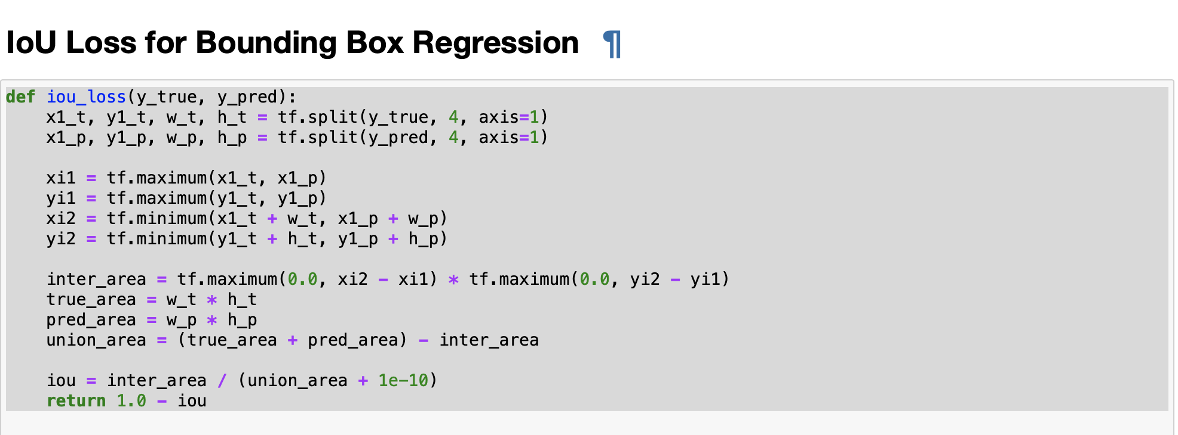

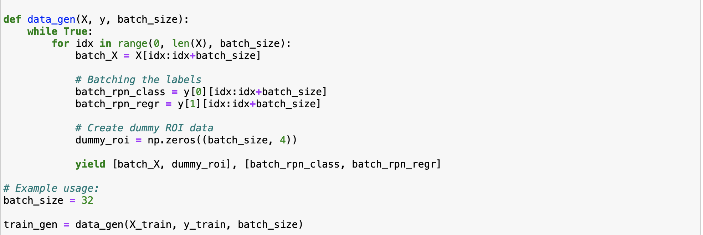

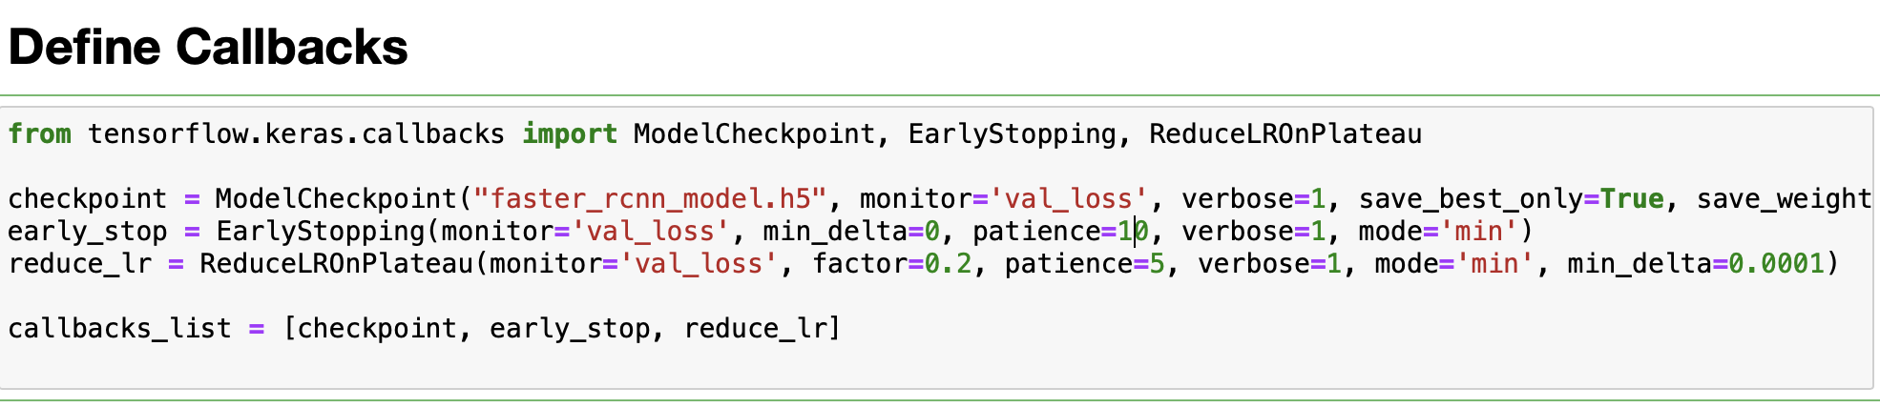

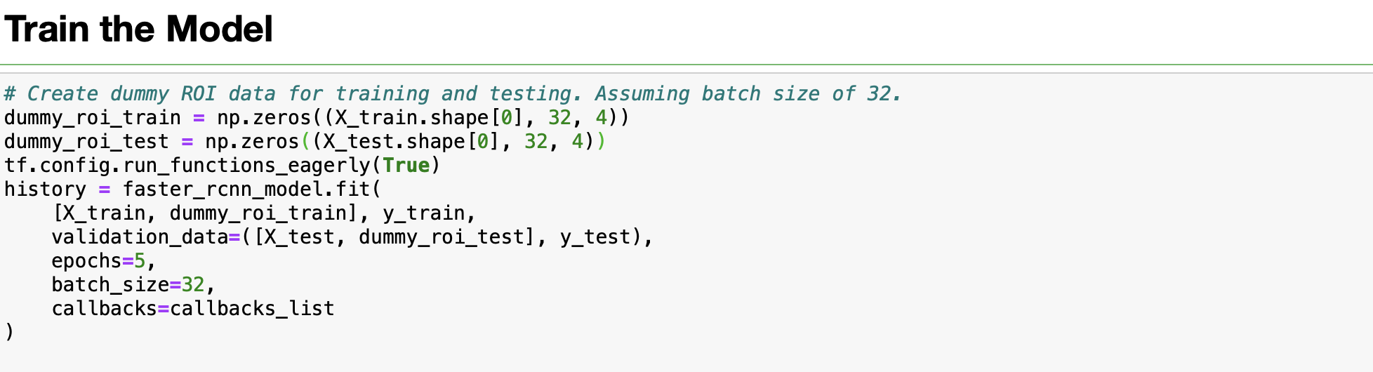

1. **Evaluation**:
   * Sampled random X-ray images and used the trained Faster R-CNN model to predict the presence of pneumonia and its location.
   * Visualized the results by overlaying predicted and ground truth bounding boxes on the X-ray images.

**Results Achieved**:

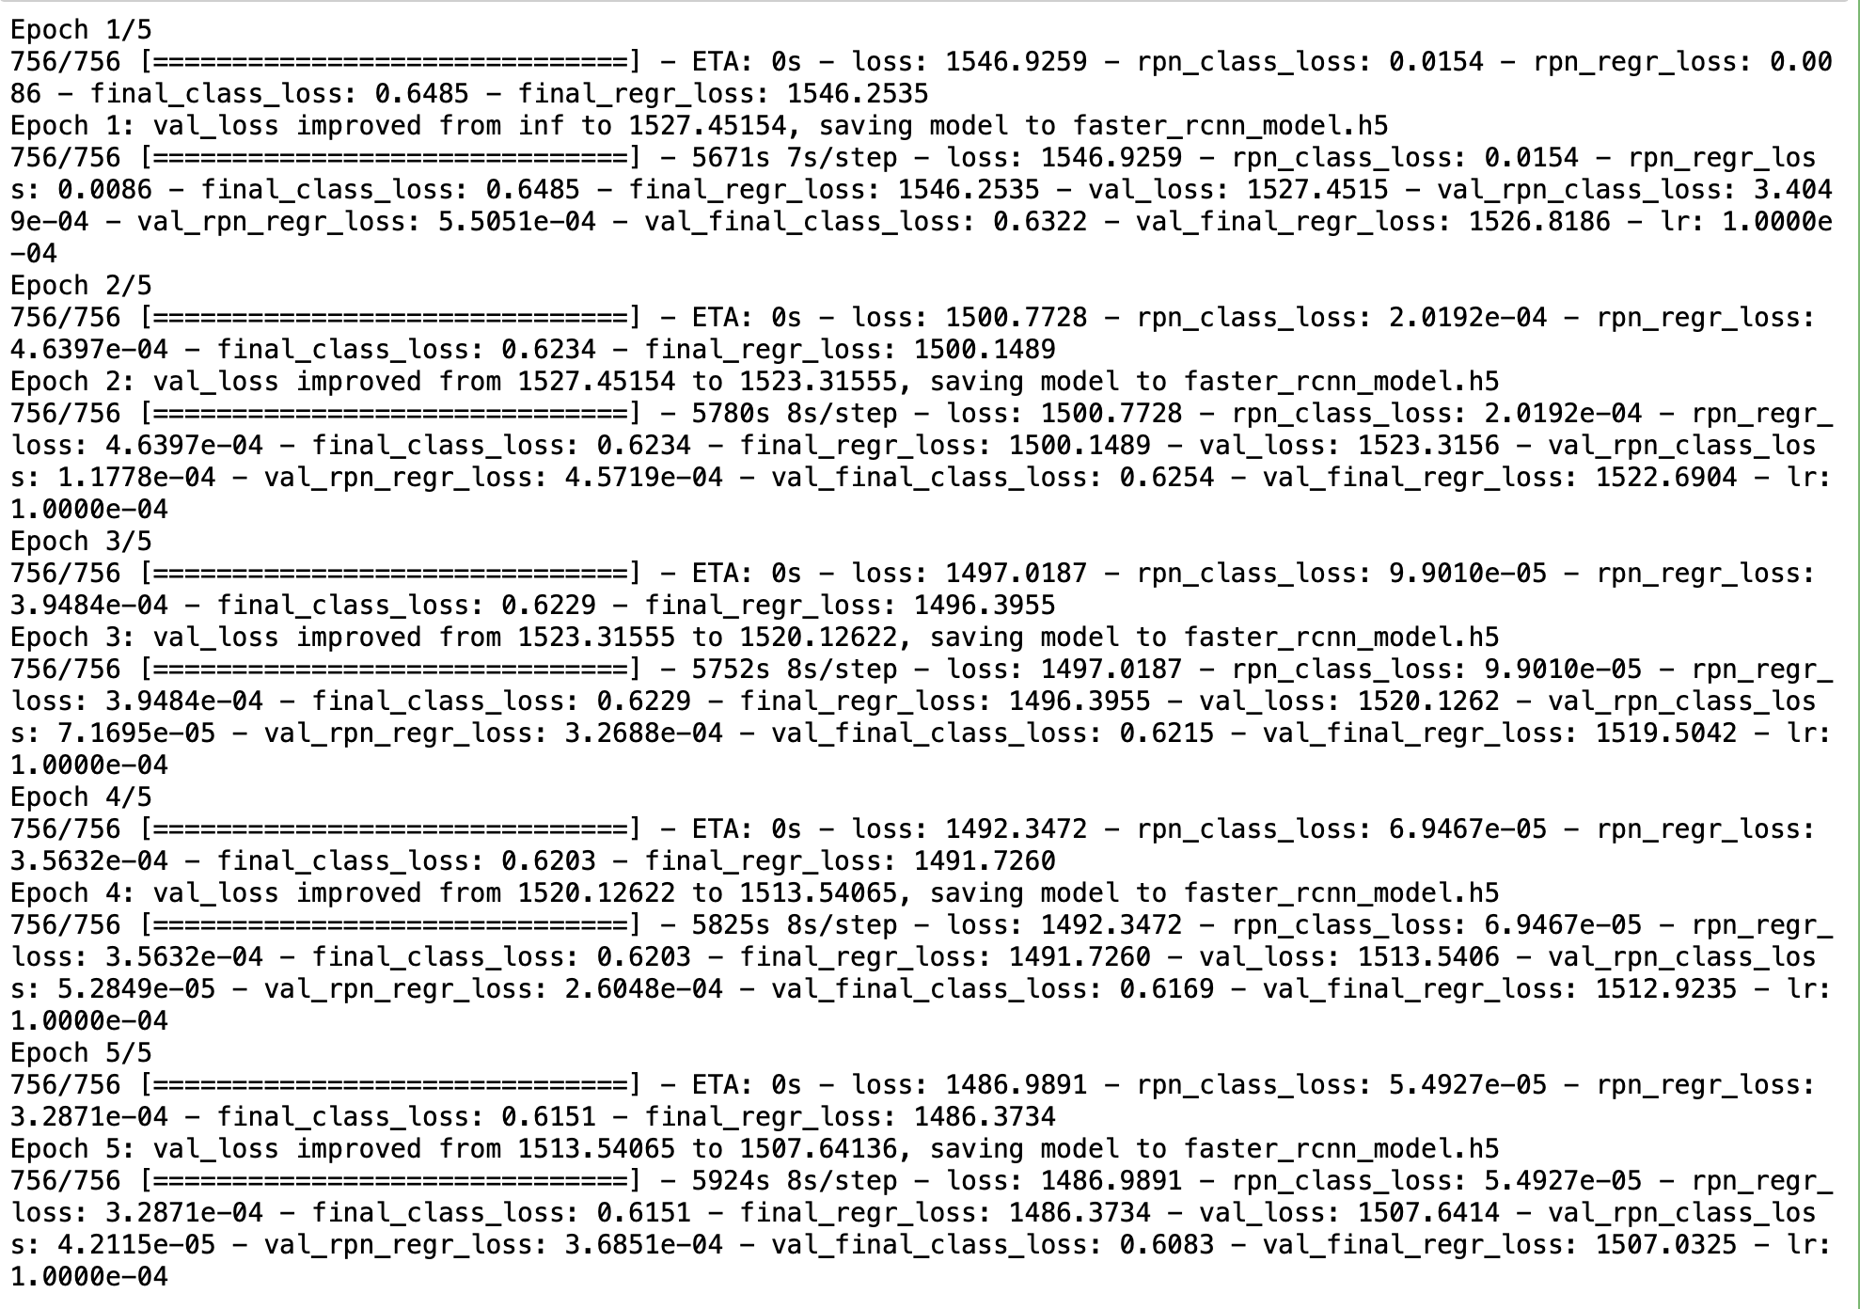

From the provided training logs:

* Over 5 epochs, there was a consistent decrease in both training and validation loss, indicating the model was learning effectively.
* The RPN class and regression losses were low, suggesting the RPN was effectively proposing regions containing objects.
* The final class and regression losses also reduced over epochs, implying the classifier and regressor were improving in predicting object classes and refining bounding boxes.

The visualizations of predictions on sample images revealed the effectiveness of the trained model. Both the actual and predicted bounding boxes were plotted, allowing for a visual comparison of the model's performance.

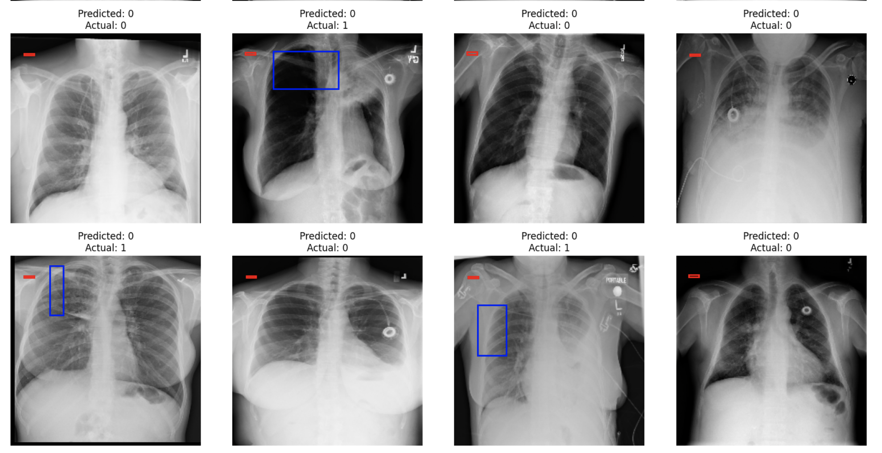

**In Reference to the Objective**:

Our aim was to design, train, and test RCNN & its hybrids based object detection models to impose bounding boxes or masks over areas of interest in chest X-ray images of pneumonia patients.

Our code achieved this by:

* Implementing a Faster R-CNN model that leverages the power of ResNet50 for feature extraction.
* Employing a Region Proposal Network (RPN) to generate region proposals.
* Using IoU as a metric to determine how well the predicted bounding boxes matched the ground truth.
* Visually inspecting the predictions to confirm the model's effectiveness in detecting and localizing pneumonia in X-ray images.

In conclusion, our implementation of Faster R-CNN was methodically executed and demonstrated promising results in detecting and segmenting pneumonia regions in chest X-ray images.

Due to limitation on computation power, this model was not trained further but looking at the results, if we trained this model further for future purposes, it could give very promising results!!!

**Conclusion**:

The primary objective of the project was to design a deep learning-based algorithm for detecting pneumonia from medical imagery. The journey commenced with fundamental steps of importing the dataset, mapping images to their classes and annotations, followed by preprocessing and visualization. Initial attempts with basic CNN models yielded an accuracy of 46%, which marginally improved to 50% upon fine-tuning.

Subsequent exploration with renowned pre-trained models like VGG16, InceptionV3, ResNet50, and others highlighted the stark differences in performance among them. Specifically, the Xception model emerged as a strong performer with a test accuracy of 34.22% and a commendable validation accuracy of 74.72%. Yet, the quest for higher accuracy led to the exploration of the U-Net model, which further improved the validation accuracy to 51%.

A breakthrough was achieved with the custom amalgamation of U-Net and ResNet, which delivered an impressive validation accuracy of 97% coupled with an Intersection over Union (IoU) of over 74%. The project culminated with the implementation of Faster R-CNN, an advanced object detection model, which further fortified the model's capability to impose bounding boxes over areas of interest.

Despite the success, the project had its limitations. All models were trained on CPU due to computational constraints, which might have influenced the performance and training duration.

**Future Enhancements**:

1. **Masked R-CNN**: To further refine the bounding boxes and ensure precise localization, adopting Masked R-CNN can be beneficial. This model not only detects the object but also generates a high-resolution object mask, making detections even more accurate.
2. **Hybrid R-CNN Models**: Incorporating hybrid architectures, which combine the strengths of various models, could lead to better performance. The success of the U-Net and ResNet combination underscores the potential of hybrid models.
3. **Training Infrastructure**: Moving from CPU to GPU or even TPU-based training can drastically reduce training times and might also improve model performance due to better optimization during quicker iterative processes.
4. **Data Augmentation**: More sophisticated data augmentation techniques can be adopted to artificially expand the dataset, ensuring better generalization.
5. **Fine-tuning**: Given the promising results from fine-tuning earlier in the project, additional fine-tuning with more layers, or different combinations of layers, could lead to further improvements.
6. **Regularization and Optimization**: Techniques like dropout, batch normalization, and advanced optimization algorithms can be integrated to enhance model robustness and performance.

In conclusion, the project has laid a strong foundation for pneumonia detection using deep learning. With further refinement and leveraging advanced architectures, the path to near-perfect detection seems plausible. The journey underscores the potential of deep learning in medical diagnostics, promising a future where such models become an integral part of healthcare systems.